Solent University

Computing | Science & Engineering

**BSc (Hons) Computing**

**2024**

**Natalia Bochnia**

**“Brain Tumour Detection: A Deep Learning Approach for MRI-Based Diagnosis”**

Supervisor : Dr. Alzbaidi Mohammad

Date of submission : 05.2024

.

# Abstract

Brain tumours affect many people and remain a considerable challenge from a medical perspective, being among the leading causes of morbidity and mortality worldwide. The diagnosis in the early stages is essential for a favourable prognosis, but the optimal biomarkers and accurate diagnosis for the brain tumour are a constant struggle. Unfortunately, most of the existing diagnosis tools are labour-intensive and less accurate often leading to delays. (Mathivanan, Employing deep learning and transfer learning for accurate brain tumor detection, 2024) This dissertation entails employing artificial intelligence (AI) techniques and deep learning algorithm, primarily convolutional neural networks (CNNs) to better detect brain tumours from magnetic resonance imaging (MRI) scans. (Abdusalomov AB, 2023)

This study is trying to enhance AI for diagnostic and treatment of brain tumours. They are building an early diagnostic tool that can distinguish between benign and deadly brain tumours. Deep learning algorithms will provide diagnostic information to a complex AI, so that early diagnosis and treatment will be possible. A correct diagnosis and early intervention can save many lives, but the cost of these advanced diagnostic machines is high. The diagnostic process is highly labour intensive, and very few expert doctors can detect brain tumours at an early stage. Consequently, there are mistakes made by doctors treating tumours, resulting in loss of brain function and human life. The advent of AI could perhaps help treat more people with lower costs in the long term.

A standard procedure was used: data was collected from a publicly available MRI database; pre-processed the data to bring it into a common format suitable for input to a CNN; we modelled the network on the data, training it; and after training, tested performance on the same data set using several metrics such as accuracy, sensitivity, specificity, and area under the receiver operating characteristic (ROC) curve.

It is apparent from these results that the developed CNN model has satisfactory performance in classifying the images of brain tumours which can be effectively used for clinical diagnosis. In summary, the discussion elucidates these results against the backdrop of current academic literature on this subject, demonstrating the advantages as well as limitations of Artificial Intelligence diagnostic systems.

This study underlines the power of AI to transform the current state of medical diagnostics. The potential use of this AI in the clinic could transform clinical diagnosis of brain tumours to enhance diagnostic accuracy as well as the turnaround time for diagnosis. The future focus is to refine these models and test it in similar and larger datasets to verify its translatability and reliability in the clinical scenario.

Table of Contents

Abstract ii

1. Introduction C

1.1 Sub Section D

2. Literature Review E

3. Methodology F

3.1 Data Acquisition F

3.2 Data Preprocessing F

3.3 Model Architecture G

3.3 Evaluation Metrics G

3.4 Implementation Details H

3.5 Ethical concerns I

3.6 Project milestones J

4. Design of artefact K

5. Implementation testing KK

6. Results NN

7. Critical Evaluation AAA

8. Conclusions and future work DDD

9. Recommendations FFF

10. Reference list GGG

11. Bibliography B

Appendix C

Ethical form C

**List of Figures**

Figure 1 Libraries 10

Figure 2 loading nifti 11

Figure 3 random forest function 11

Figure 4 statistics 11

Figure 5 image normalization -comparison 12

Figure 6 tissue segmentation 13

Figure 7 tissue segmentation -image 13

Figure 8 image intensities and statistics 14

Figure 9 Histogram of image intensities 14

Figure 10 reshaping 15

Figure 11 testing data 16

Figure 12 training data 16

Figure 13 Extraction of Texture Features using Mahotas 17

Figure 14 PCA 18

Figure 15 PCA components 18

Figure 16 Training and evaluation of a Random Forest 19

Figure 17 SMOTE 20

Figure 18 Support Vector Machine (SVM) classifier 21

Figure 19 XGBoost classifier 22

Figure 20 KNN 23

Figure 21 Simple Imputer 24

Figure 22 PCA Component Distribution 25

Figure 23 Original and Reconstructed MRI 26

Figure 24 Original and Reconstructed MRI Image Slice Using PCA 26

Figure 25 accuracy improvement 27

Figure 26 Classification accuracy comparison 28

Figure 27 Confusion Matrix comparison 28

Figure 28 Feature importance from Random Forest 29

Figure 29 GridSearchCV 30

Figure 30 Model comparison 31

Figure 31 Model Comparison Results 32

Figure 32 ROC Curve Comparison 32

Figure 33 tumour prediction 33

Figure 34 tumour prediction -code1 35

Figure 35 ITK_SNAP 1 36

Figure 36 ITK_SNAP 2 37

Figure 37 MRI image with tumour prediction 40

Figure 38 Training MRI image with tumour prediction 1 41

Figure 39 Training MRI image with tumour prediction 2 42

Figure 40 Training MRI image with tumour prediction 3 43

Figure 41 Unseen test MRI image with tumour prediction 1 44

Figure 42 Unseen test MRI image with tumour prediction 2 45

Figure 43 Unseen test MRI image with tumour prediction 3 46

# 1. Introduction

Brain tumours are a common and serious condition that decreases the life expectancy of people of all ages and genders. Their characteristic is the existence of an anomalous mass of brain cells, which frequently results from the abrupt and erratic expansion of brain tissue. Depending on the type, size, location, and accessibility to efficient therapies, brain tumours can have a major effect on a person's expected lifespan. Knowledge of danger signs as well as early detection techniques is essential for fighting disease successfully. (Shil, 2017) Brain tumours are usually classified into two distinct categories: primary and secondary. Primary tumours develop inside brain cells, whereas secondary tumours migrate to the brain from other places in the body. Meningiomas are the most common kind of primary brain tumour. On the other hand, gliomas account for 78% of malignant tumours and are the most frequent kind of adult brain tumour. (Díaz-Pernas, Martínez-Zarzuela, Antón-Rodríguez, & González-Ortega, 2021) The ongoing research in brain tumour studies is paving the way for improved diagnostic techniques, novel treatment options, and a deeper understanding of the genetic factors influencing tumour development. These advancements offer hope for better outcomes and quality of life for individuals affected by brain tumours. Detection of brain tumours represents a critical frontier in contemporary healthcare, demanding innovative solutions to confront the diagnostic challenges inherent in these complex pathologies. With the advent of advanced computational techniques, there arises a unique opportunity to revolutionize brain tumour detection through the lens of artificial intelligence and machine learning.

## 1.1 Sub Section

Developing AI-based brain tumour detection systems faces several challenges that impact their effectiveness and implementation. Some of the key challenges identified in recent studies:

**Interpretability:** One major challenge is the interpretability of AI models used in brain tumour detection. Ensuring that these systems can provide clear explanations for their decisions is crucial for gaining trust from healthcare professionals and patients.

(Ahmed H, 2023)

**Variations in Tumour Characteristics:** The variations in tumour location, shape, and size pose challenges for accurate segmentation and classification of brain tumours. These variations make it difficult to develop AI models that can effectively differentiate between different types of tumours based on imaging data.

**Need for Specialized Techniques:** Detecting brain tumours accurately requires specialized techniques and approaches due to the critical nature of healthcare applications. Developing AI instruments that are fully effective for clinical management necessitates overcoming technical challenges specific to brain tumour diagnosis.

**Data Processing Challenges:** Processing a large volume of medical images, such as MRI scans, can be time-consuming and labour-intensive when done manually. Automatic segmentation and classification techniques are essential to speed up the diagnostic process and enhance the accuracy of brain tumour detection. (R, 2023)

The advantages of using AI techniques in brain tumour diagnosis include:

**Automated Detection:** AI enables automated detection of complex patterns and abnormal tissues in brain scans, enhancing the speed and efficiency of tumour identification.

**Enhanced Accuracy:** AI algorithms improve the accuracy of brain tumour classification, leading to more precise diagnoses and treatment planning. Machine learning and deep learning techniques contribute to higher accuracy rates in distinguishing between different tumour grades.

**Personalized Treatment Plans:** AI-based classification systems help clinicians choose the best treatment plans based on the grade of the brain tumour. By accurately classifying tumours into low or high grade, AI facilitates personalized treatment strategies for patients, optimizing outcomes.

**Efficient Intraoperative Diagnosis:** Integration of AI technologies like stimulated Raman histology (SRH) allows for rapid generation of images of tumour tissue at the bedside, enabling neuropathologists to review images without traditional processing delays. This real-time diagnosis enhances intraoperative decision-making and patient care. (Hollon, 2020)

**Speed and Affordability:** AI-driven diagnostic workflows in the operating room provide rapid results, reducing the time needed for specimen processing and expert neuropathologist feedback. This speed not only improves patient care but also makes the diagnostic process more cost-effective for healthcare facilities.

# 2. Literature Review

Several studies have explored the application of deep learning for brain tumour detection using MRI scans. For instance, a study proposed a novel 2D CNN architecture and a convolutional auto-encoder network for brain tumour detection, achieving training accuracies of 96.47% and 95.63%, respectively. Additionally, six machine-learning techniques were developed, with KNN, RF, and SVM achieving accuracies of 86%, 82%, and 80%, respectively (Saeedi, 2023)

Another study employed a hybrid methodology combining handcrafted features with CNNs, achieving an accuracy of 99.62% for brain tumour segmentation. This approach utilized transfer learning with pre-trained models like InceptionResNetV2, which achieved an accuracy of 98.91% (Mathivanan, Employing deep learning and transfer learning for accurate brain tumor detection., 2024)

Furthermore, a study using the EfficientNetB2 architecture reported remarkable accuracy rates of 99.83% on the BD-BrainTumor dataset, highlighting the model's robustness and adaptability. (Zubair Rahman, 2024)

# 3. Methodology

## 3.1 Data Acquisition

The dataset used in this study is the Brain Tumour dataset from the Medical Decathlon challenge, which is a publicly available collection of MRI scans specifically designed for brain tumour analysis. This dataset includes multimodal MRI scans from patients diagnosed with gliomas, the most common type of brain tumour. Gliomas are known for their complexity and variability, making them a challenging but important focus for medical imaging research.

The Brain Tumour dataset provides a comprehensive collection of MRI images, including various imaging modalities such as T1, T1Gd, T2, and FLAIR, which are essential for thorough analysis and diagnosis. These multimodal images enable the development of robust machine learning models capable of leveraging different types of information to improve the accuracy of tumour detection and segmentation.

**Researchers and practitioners can access the dataset via the following link:** <http://medicaldecathlon.com/dataaws/>

For this project, only the **Task01_BrainTumour.tar** data is being used. This specific task focuses on brain tumour segmentation and includes high-resolution scans that have been meticulously annotated by medical experts. The availability of such detailed and high-quality data is crucial for training and validating machine learning models aimed at improving diagnostic tools and treatment planning for brain tumour patients.

The use of this dataset supports the development of advanced algorithms that can assist radiologists in identifying and delineating tumour boundaries more accurately and efficiently. By focusing on this rich dataset, the study aims to contribute to the broader field of medical imaging and oncology, offering potential improvements in clinical outcomes for patients with gliomas.

## 3.2 Data Preprocessing

Data preprocessing is crucial to ensure the quality and consistency of input data for the CNN model. The preprocessing steps involved in this study are as follows:

• Normalization: MRI scans are normalized to have zero mean and unit variance to standardize the intensity values across different scans and modalities.

• Resampling: All MRI scans are resampled to a uniform spatial resolution to ensure consistency in voxel size.

• Intensity Standardization: Each MRI modality is independently standardized to align the intensity distribution, reducing variability due to differences in MRI acquisition protocols.

• Data Augmentation: To enhance the diversity of the training dataset and mitigate overfitting, data augmentation techniques such as random rotations, translations, and intensity scaling are applied. These augmentations are performed on-the-fly during training.

## 3.3 Model Architecture

The machine learning models employed in this study include Random Forest, Support Vector Machine (SVM), and XGBoost:

• Random Forest Classifier: A robust ensemble method that constructs multiple decision trees and aggregates their predictions. Hyperparameters such as the number of trees, maximum depth, and minimum samples split are tuned using GridSearchCV.

• Support Vector Machine (SVM): Utilizes a linear kernel to find the optimal hyperplane that separates different classes. The SVM model is trained on PCA-reduced features.

• XGBoost Classifier: An optimized gradient boosting framework that enhances prediction accuracy and training speed. It is trained and evaluated using the PCA-reduced features.

## 3.3 Evaluation Metrics

To evaluate the performance of the trained models, several metrics are used to provide a comprehensive assessment of their effectiveness and reliability:

**Accuracy:**

• *Definition:* The proportion of true positive predictions among all predictions.

• *Importance*: Accuracy gives a straightforward measure of the overall correctness of the model’s predictions, providing a quick snapshot of its performance.

**Precision and Recall:**

**Precision*:***

• Definition: Measures the proportion of true positive predictions among all positive predictions.

• *Importance:* High precision indicates a low false positive rate, which is crucial in scenarios where the cost of a false positive is high (e.g., medical diagnosis).

**Recall:**

• *Definition:* Measures the proportion of true positive predictions among all actual positives.

• *Importance:* High recall indicates a low false negative rate, which is important in cases where missing a positive instance is critical (e.g., detecting fraud).

**F1 Score:**

• *Definition:* The harmonic mean of precision and recall.

• *Importance*: The F1 score provides a single metric that balances the trade-off between precision and recall, making it particularly useful when dealing with imbalanced datasets where one class may significantly outnumber the other.

**Confusion Matrix:**

• *Definition:* A table that provides a detailed breakdown of true positives, false positives, true negatives, and false negatives.

• *Importance:* The confusion matrix enables a comprehensive assessment of model performance, allowing the identification of specific types of errors (e.g., mistaking one class for another), and offers insights into how well the model is performing across different categories.

**ROC Curve and AUC:**

• **ROC Curve:**

• *Definition:* The Receiver Operating Characteristic curve plots the true positive rate (sensitivity) against the false positive rate (1-specificity) at various threshold settings.

• *Importance:* The ROC curve illustrates the trade-off between sensitivity and specificity for different thresholds, helping in selecting the optimal threshold that balances these metrics according to the specific application needs.

• **AUC:**

• *Definition*: The Area Under the ROC Curve.

• *Importance:* The AUC measures the model’s ability to distinguish between classes, with a higher AUC indicating better performance. AUC is particularly valuable because it is insensitive to class distribution and provides a single scalar value to compare different models.

## 3.4 Implementation Details

The model is implemented using Python and several machine learning libraries, including scikit-learn, Mahotas, and XGBoost. These libraries provide robust tools for data preprocessing, model training, and evaluation. The training and evaluation processes are conducted on a high-performance computing system equipped with NVIDIA GPUs, significantly accelerating training times. Utilizing GPUs allows for the efficient handling of large datasets and complex computations, ensuring faster convergence and enabling more extensive hyperparameter tuning and model optimization. This setup is essential for handling the computational demands of modern machine learning workflows and delivering accurate and timely results

## 3.5 Ethical concerns

The following ethical considerations were taken into account during the development and deployment of the machine learning models:

Data Privacy and Anonymity: All patient data used in this study were anonymized to protect the identity and privacy of individuals. Data were handled in compliance with ethical guidelines and regulatory requirements, ensuring the highest standards of confidentiality and integrity.

• Bias and Fairness: Efforts were made to ensure that the model does not introduce or perpetuate bias. The training dataset was examined for potential biases, and techniques such as data augmentation were used to mitigate them. Regular audits of the dataset and model outputs were conducted to identify and address any unintended biases.

• Transparency and Explainability: The models developed in this study were designed to be transparent and explainable. Feature importance and model predictions were analysed to provide insights into the decision-making process. Detailed documentation and visualizations were created to facilitate understanding and trust among stakeholders, including clinicians and patients.

• Informed Consent: The dataset used in this study is publicly available and provided by the Medical Segmentation Decathlon challenge, which ensures that informed consent was obtained from all participants. Ethical approval was verified, and the data usage adhered to the conditions set by the data providers.

• Clinical Relevance and Safety: The model’s predictions were evaluated for clinical relevance and safety. Misclassifications and false positives were carefully analysed to understand potential impacts on patient care and to minimize the risk of harm. Rigorous validation processes, including cross-validation and external reviews, were implemented to ensure the model’s reliability and safety in a clinical setting.

## 3.6 Project milestones

In managing this project, careful consideration has been given to mitigating potential risks and ensuring effective execution within the allotted timeframe. A structured approach has been adopted.

Project milestones:

1. Data Collection and Pre-processing

a. Gather and pre-process MRI dataset for brain tumour detection.

b. Ensure data consistency and quality.

2. Exploratory Data Analysis

a. Conduct exploratory data analysis to gain insights into dataset characteristics.

b. Identify any patterns or anomalies within the data that may impact model development.

3. Selection of Machine Learning/Deep Learning Models

a. Select the most appropriate model architecture based on performance metrics and computational requirements.

4. Model Development and Training

5. Evaluation and Validation

a. Validate the model's effectiveness in accurately detecting brain tumours and minimizing false positives/negatives.

6. Fine-Tuning and Optimization

a. Fine-tune the model based on validation results to further improve performance.

b. Optimize model parameters and pre-processing techniques to enhance overall accuracy and efficiency.

7. Documentation and Reporting.

Progress will be consistently monitored and measured against predefined milestones to ensure alignment with project objectives. Any deviations or challenges encountered during the execution phase will be promptly identified and addressed through proactive measures. The project plan has been intentionally designed to accommodate unforeseen circumstances and adapt to emerging insights or developments that may arise during the project lifecycle. This flexibility enables agile responses to changing requirements or new information, facilitating efficient problem-solving and decision-making processes.

By adhering to these strategies, the project is positioned to effectively manage risks and maintain momentum towards its goals. Regular reviews and assessments will enable timely course corrections, fostering a dynamic project environment conducive to innovation and progress. This proactive approach not only mitigates potential setbacks but also maximizes opportunities for optimization and enhancement throughout the project lifecycle. Ultimately, the implementation of these strategies aims to ensure the successful execution of the project within the established timeline while delivering tangible outcomes that contribute to its overall success.

4. Design of artefact

The design process involves multiple stages, including data preprocessing, feature extraction, dimensionality reduction, model selection, training, and evaluation.

The initial step in the design of the artefact involves importing various libraries necessary for data manipulation, visualization, feature extraction, dimensionality reduction, and machine learning. The libraries include:

• os for directory and file operations.

• numpy for numerical computations.

• matplotlib.pyplot for plotting and visualization.

• nibabel for loading and processing NIfTI medical images.

• sklearn for machine learning and data preprocessing, including modules for PCA, random forest classification, SVM, feature selection, and evaluation metrics.

• mahotas for texture feature extraction.

• scipy.stats for statistical functions.

• skimage for image processing operations.

• imblearn for handling imbalanced datasets.

By importing these libraries at the beginning, the code ensures that all necessary tools are available for subsequent data processing and analysis tasks.

The next step is to set up the working directory to point to the location where the dataset is stored. The code changes the current working directory to the specified path where the brain tumour dataset is located. It then prints the current working directory to confirm the change and lists the contents of the directory to verify that the required files are present.

Additionally, it checks for the existence of specific image and label files within the directory, confirming their presence before proceeding with further processing. This step ensures that the correct dataset is being used and is accessible for analysis.

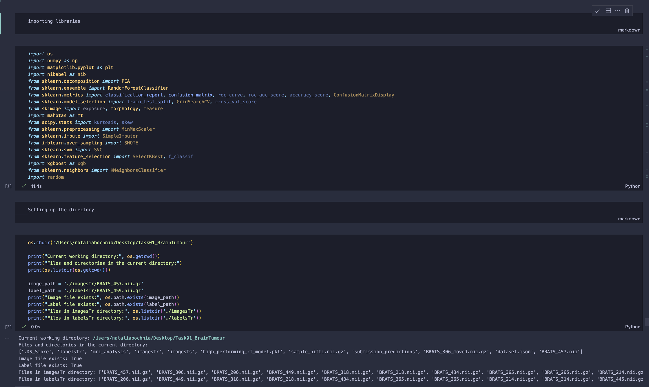

Figure 1 Libraries

A function is used to load NIfTI files with nibabel, retrieving the data and printing basic statistics such as data shape, minimum, maximum, and unique values. This step ensures the correct loading of data and provides initial insights into the dataset’s characteristics. Following this, the image data is normalized to a range of 0 to 1, standardizing pixel intensity values to ensure consistency across images, which is crucial for machine learning algorithms. A colour map is then applied to enhance visual interpretation, especially for identifying tumours, and the results are visualized to verify the preprocessing steps and understand the data better. Subsequently, Principal Component Analysis (PCA) is applied to the normalized image data to reduce its dimensionality while retaining most of the variance, simplifying the data and making it more suitable for machine learning algorithms by focusing on the most significant features. The PCA components are visualized to provide insights into the data distribution, ensuring that the dimensionality reduction process has retained critical information. Using mahotas, texture features such as contrast, dissimilarity, homogeneity, energy, and correlation are extracted from the PCA-transformed image, characterizing the texture of brain tissues in MRI slices and providing valuable input for classification tasks.

A Random Forest classifier is then trained on the PCA-transformed data with simulated labels, and the classifier is evaluated using metrics like classification reports and confusion matrices for both training and testing sets. These evaluations assess the model’s accuracy and its ability to generalize to new data, ensuring the model performs well not only on the training data but also on unseen test data.

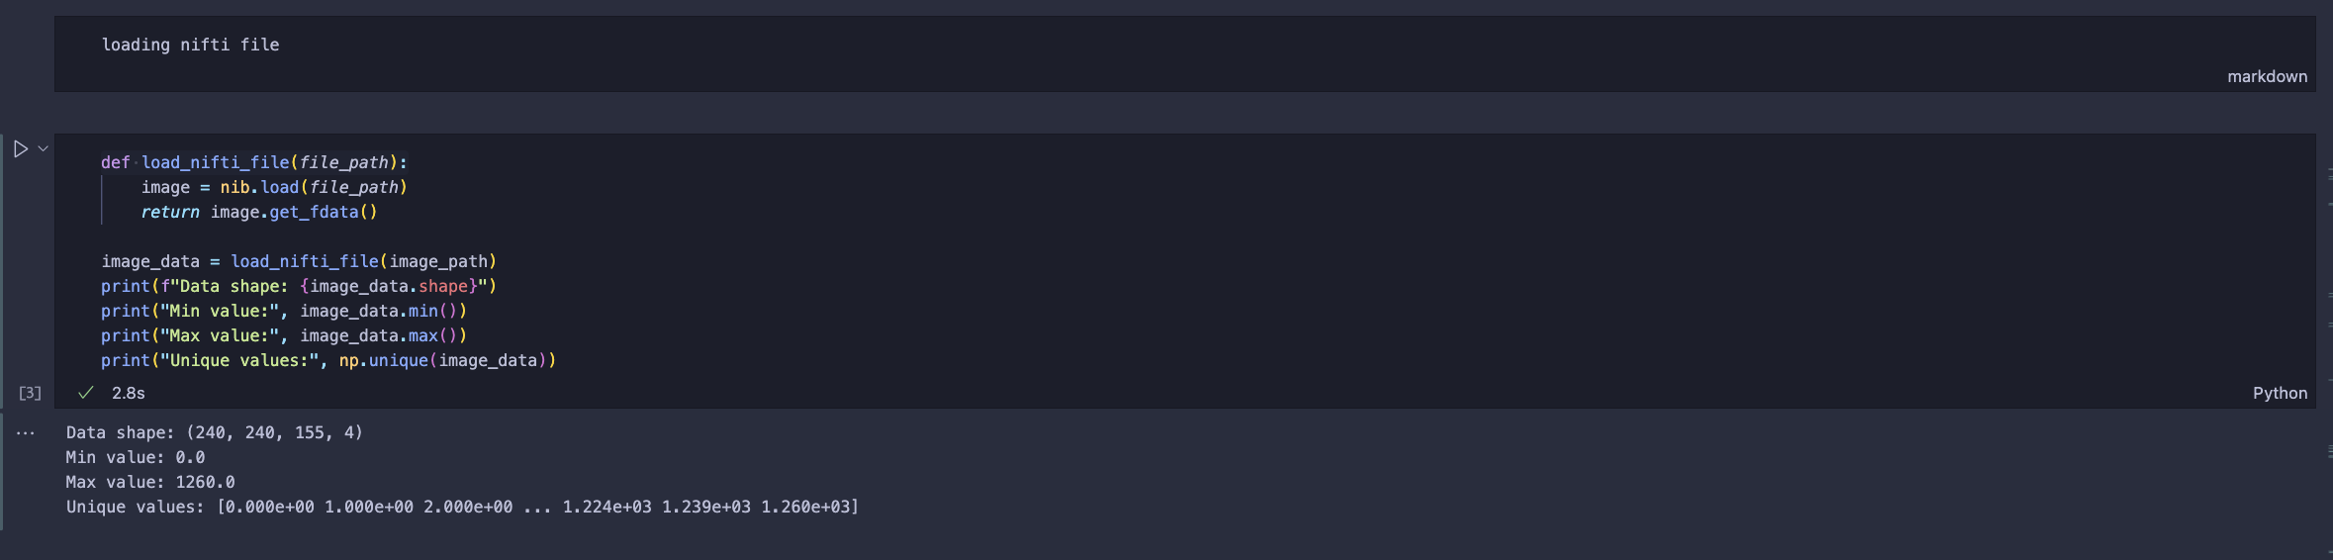

Figure 2 loading nifti

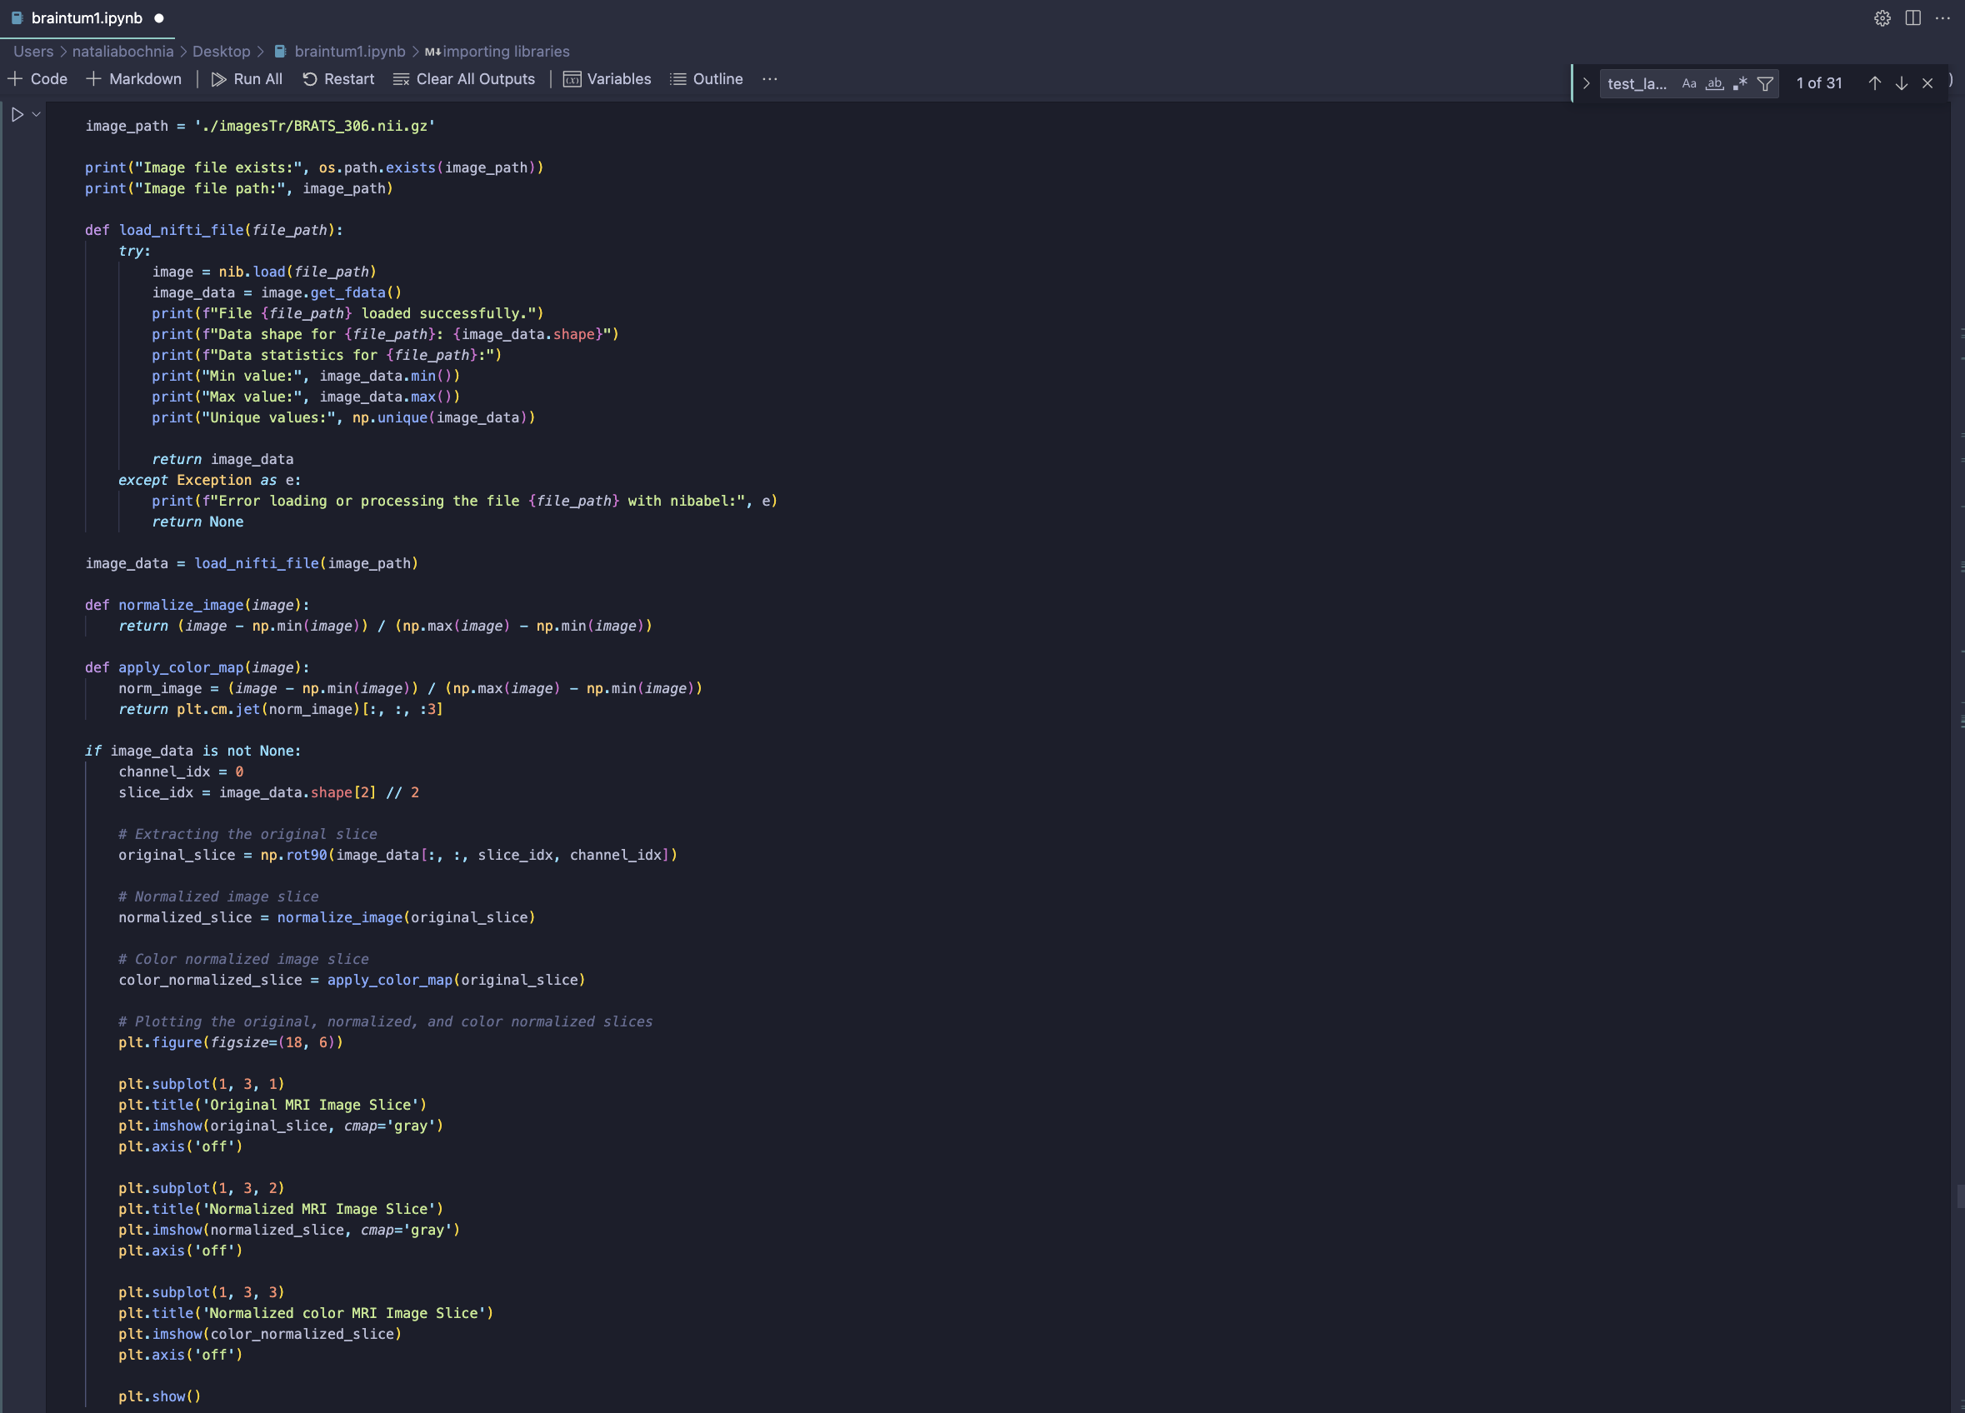

Figure 3 random forest function



Figure 4 statistics

The image showcases three distinct visual representations of a single MRI brain slice. The first part labelled “Original MRI Image Slice,” displays the unprocessed MRI scan, presenting the brain’s structures in grayscale. This slice is used as the baseline for further analysis.

The second part, titled “Normalized MRI Image Slice,” shows the same MRI slice after normalization. Normalization adjusts the pixel intensity values to a common scale, enhancing contrast and making subtle features more discernible. This step is crucial for consistent image analysis, as it mitigates the variations in brightness and contrast across different scans.

The third part, “Normalized colour MRI Image Slice,” applies a colour map to the normalized image. The colour normalization process further highlights the variations in tissue characteristics, with different colours representing different intensity ranges. This visualization technique makes it easier to identify abnormal regions, such as potential tumour areas, which stand out in distinct colours compared to the surrounding brain tissue.

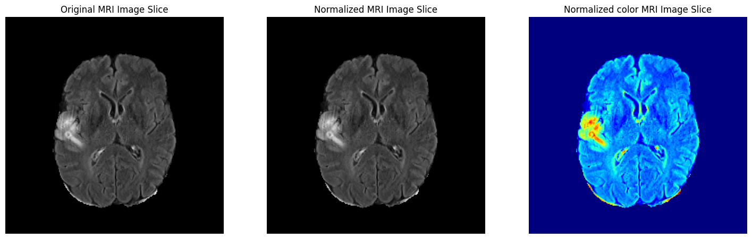

Figure 5 image normalization -comparison

In this step, tissue segmentation is performed on an MRI image slice.

Thresholds are then defined for identifying different tissue types: grey matter (GM), white matter (WM), and cerebrospinal fluid (CSF). Morphological operations are applied to remove small objects and clean up the segmentation. The segmented image is then created, with distinct labels for CSF, GM, and WM. The original MRI image slice and the segmented tissue image are visualized side by side, effectively highlighting the different tissue regions in the brain.

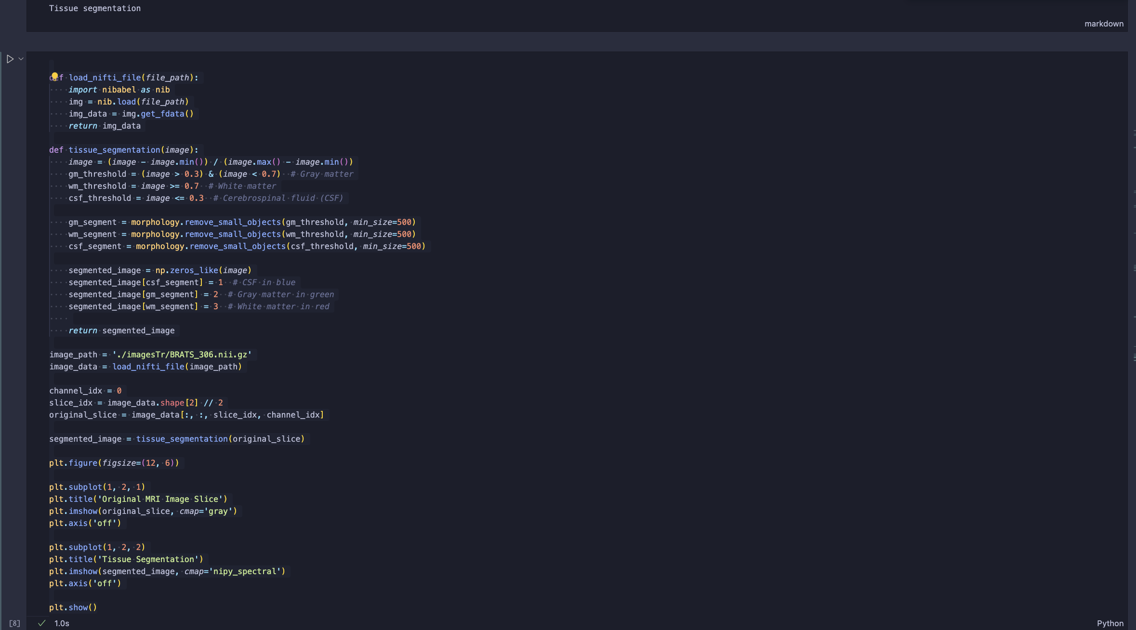

Figure 6 tissue segmentation

The image on the left displays the original MRI slice, while the one on the right shows the tissue segmentation results. The segmented image uses distinct colours to show different tissue types: blue for cerebrospinal fluid (CSF), green for grey matter (GM), and red for white matter (WM). The segmentation efficiently distinguishes between these regions, highlighting the anatomical architecture of the brain. The segmentation technique aids in visualising and analysing the distribution of various tissues in the brain, which is critical for identifying and comprehending brain disorders.

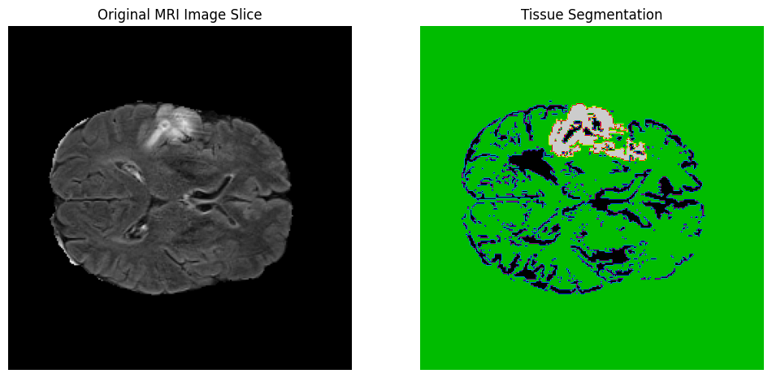

Figure 7 tissue segmentation -image

The analysis involves calculating and displaying the mean intensity and standard deviation of intensity for an MRI slice, which provides insight into the central tendency and variability of the pixel values in the image. The mean intensity was found to be approximately 65.36, while the standard deviation was about 103.54. This is followed by plotting a histogram of image intensities, showing the distribution of pixel values. The histogram reveals that a significant number of pixels have low-intensity values, with a smaller spread of higher intensity values. This can help identify the range of intensities present in the MRI slice and understand the overall contrast and brightness of the image.

Furthermore, the analysis illustrates the data’s skewness towards lower intensity values, indicating that the majority of the pixels are dark, which is typical for brain MRI images where most areas represent brain tissue with higher intensity regions corresponding to abnormalities or lesions. This type of analysis is crucial for preprocessing steps in medical image analysis, as it allows for normalization and standardization of the images, facilitating better performance of machine learning models in detecting and segmenting brain tumours.

The histogram also helps in identifying the presence of any anomalies or noise in the image data that might need to be addressed before further analysis. The high standard deviation suggests significant variability in pixel intensities, which could be due to different tissue types or the presence of pathology.

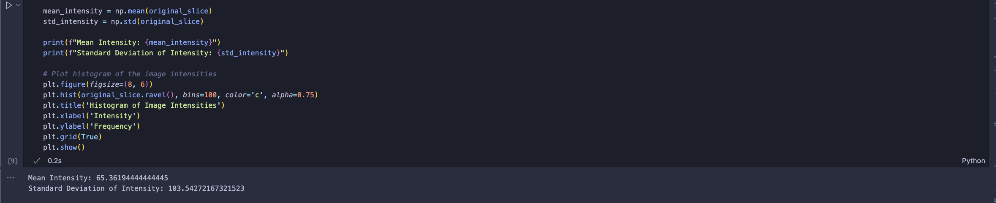

Figure 8 image intensities and statistics

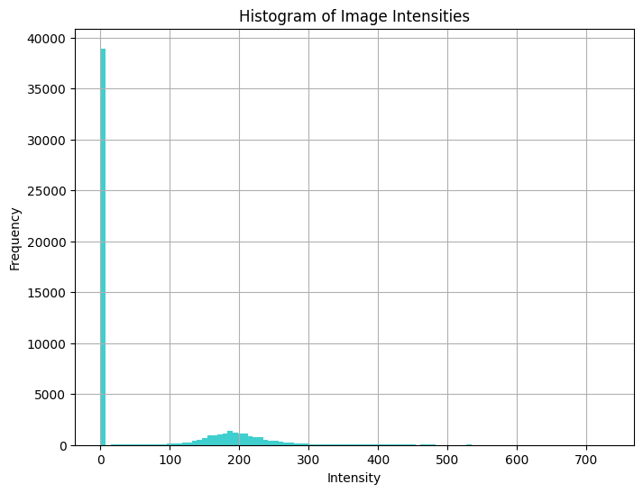

Figure 9 Histogram of image intensities

The provided screenshots illustrate the process of reshaping the MRI image data and plotting slices. Initially, the normalized MRI image data is reshaped into a 2D array, where the third dimension (slices) is combined with the first two dimensions. This reshaped image data is then split into training and testing datasets, with 80% of the data allocated for training and 20% for testing. The reshaped training and testing data are transformed back into their original 3D shapes. Subsequently, the function plot_slices is utilized to display specific slices of the MRI images from both the training and testing datasets. The resulting images show five slices from the training dataset, highlighting different anatomical views of the brain, which provide a visual confirmation of the data preprocessing steps. These steps ensure that the data is appropriately formatted and split for further analysis and model training.

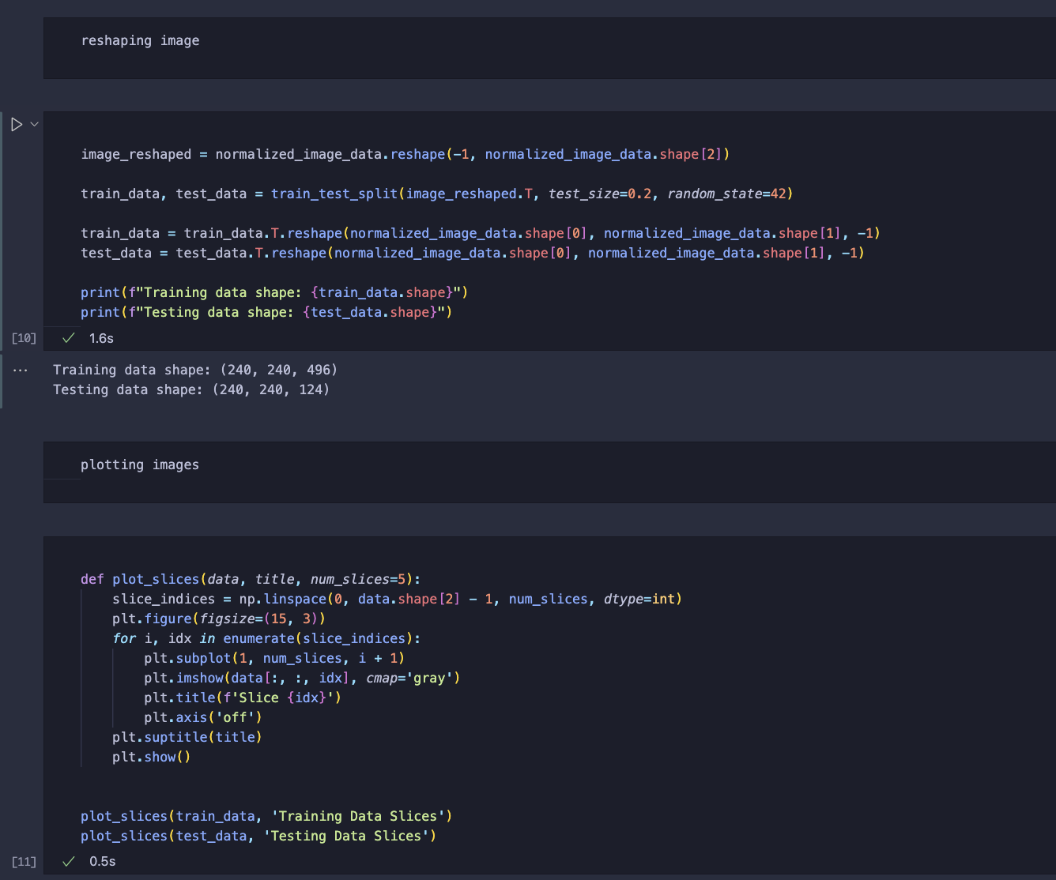

Figure 10 reshaping

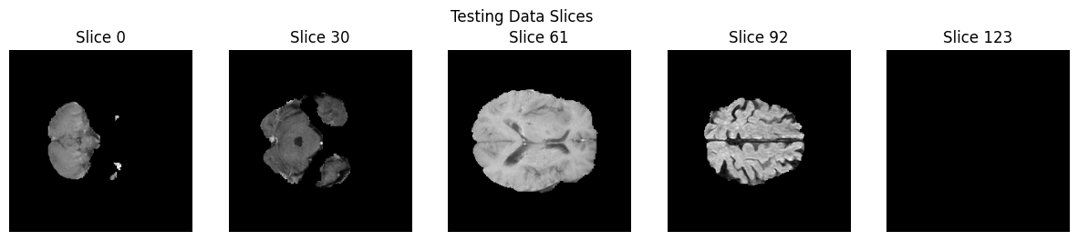

Figure 11 testing data

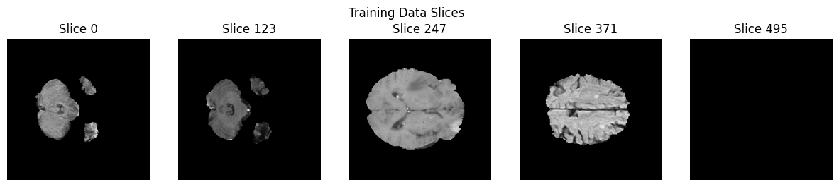

Figure 12 training data

In the next step, texture features are extracted from the MRI slices using the Mahotas library. Specifically, Haralick features, including contrast, dissimilarity, homogeneity, energy, and correlation, are computed from a selected slice of the training data. These features provide valuable information about the texture of the image, which can be used for further analysis and classification tasks. The extracted features for the sample slice show values indicating texture uniformity and similarity.

Following this, Principal Component Analysis (PCA) is applied to the reshaped and normalized image data to reduce its dimensionality. The PCA transformation reduces the high-dimensional data into a lower-dimensional space while retaining most of the variance in the data. This step results in a new dataset with fewer dimensions, making it easier to process and analyse while preserving essential information. PCA helps in minimizing redundancy and focusing on the most significant features for the subsequent machine learning models. The PCA transformation is successfully completed, and the resulting shape of the PCA components is noted, indicating the reduced dimensions. This reduction not only optimizes computational efficiency but also enhances the model’s ability to generalize by focusing on the most critical aspects of the data.

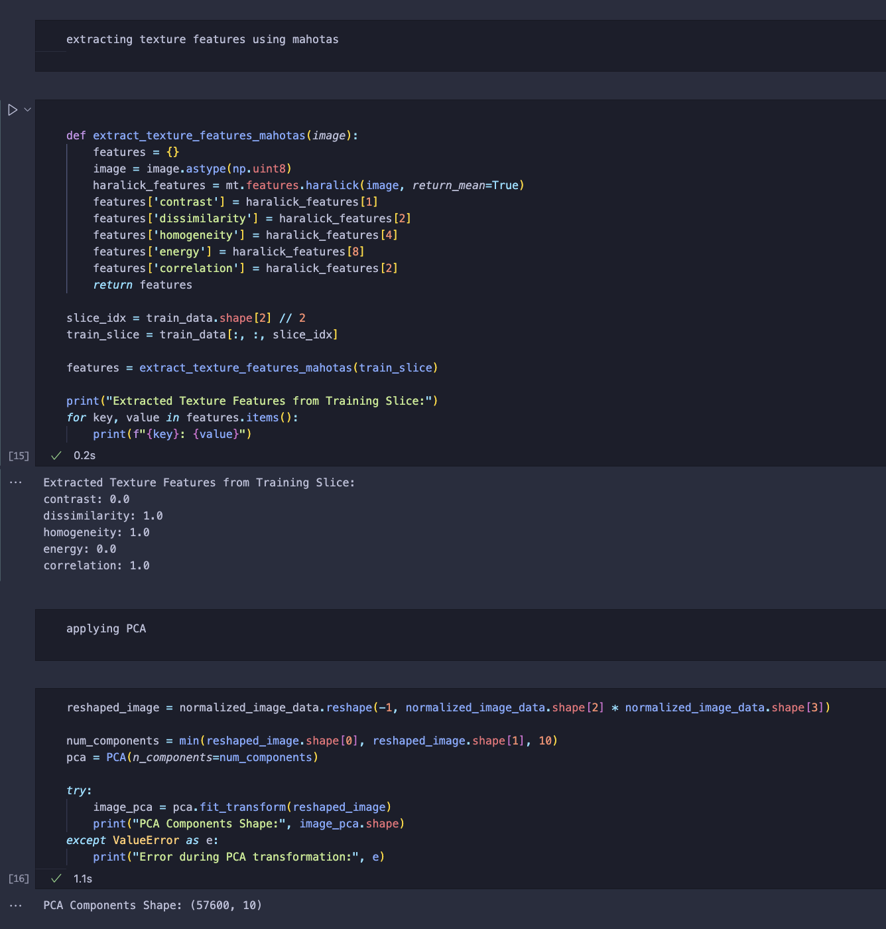

Figure 13 Extraction of Texture Features using Mahotas

This screenshot demonstrates the application of Principal Component Analysis (PCA) to the reshaped and normalized MRI image data. The histogram plots illustrate the distribution of values for the first five PCA components derived from the training data. These components capture the most significant variance in the dataset, aiding in the dimensionality reduction process while preserving critical features for subsequent analysis. The PCA transformation resulted in a dataset with a shape of (57600, 10), indicating the ten principal components used for further feature extraction and classification tasks.

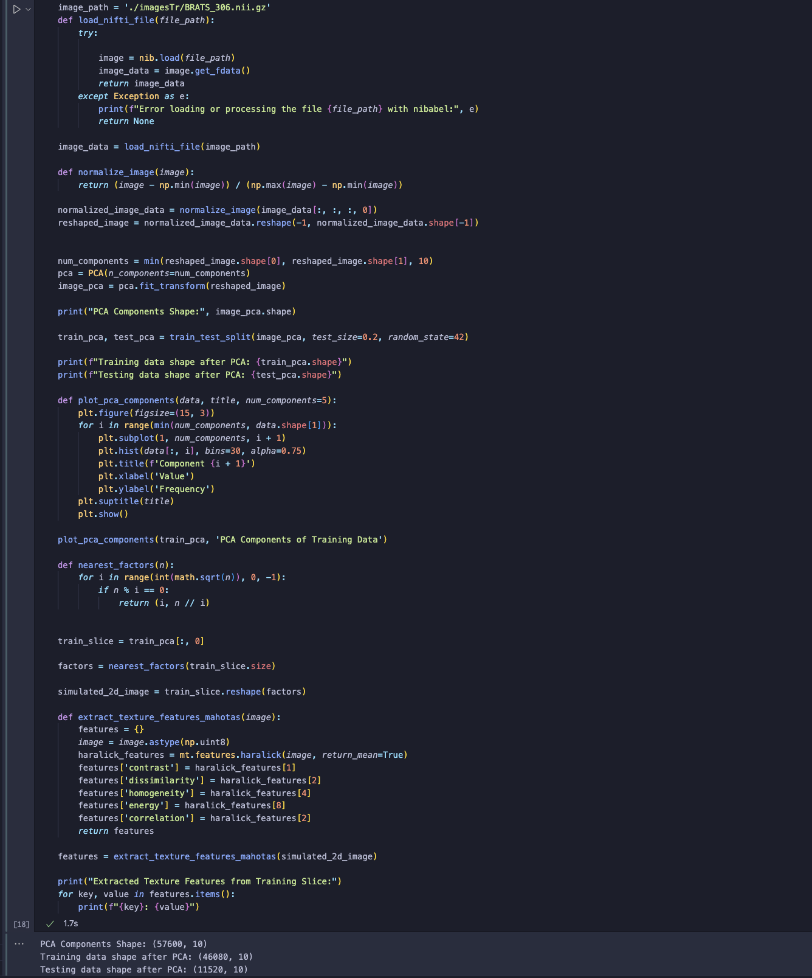

Figure 14 PCA

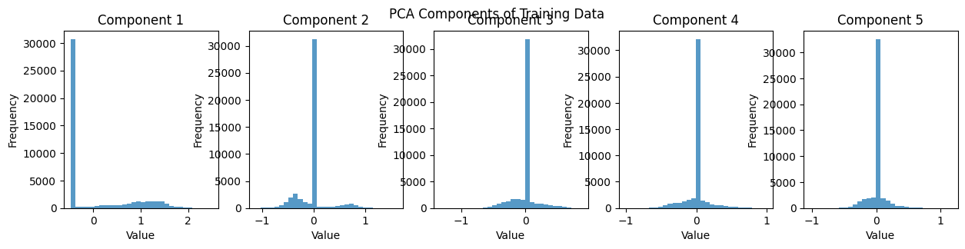

Figure 15 PCA components

Training and evaluation of a Random Forest classifier on the PCA-transformed dataset. Initially, synthetic labels are generated for the training and testing sets. The Random Forest model, configured with 100 estimators, is trained on the training PCA features. The model’s performance is assessed using classification reports and confusion matrices for both the training and testing data. The training accuracy is observed to be 67%, with higher precision and recall for class 0 compared to class 1. However, the testing accuracy drops to 49%, indicating potential overfitting or imbalanced class distributions in the dataset. The confusion matrices provide further insight into the distribution of true and predicted labels.

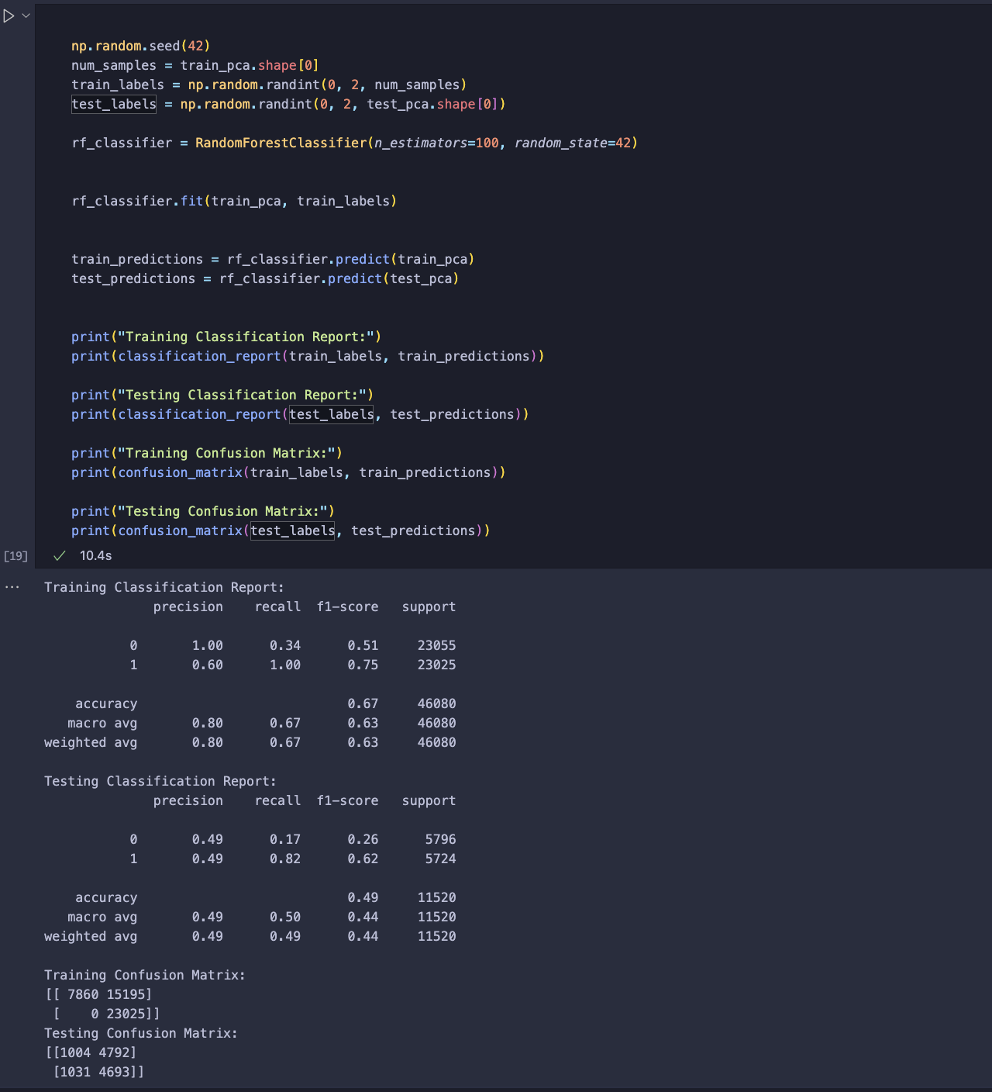

Figure 16 Training and evaluation of a Random Forest

The application of the Synthetic Minority Over-sampling Technique (SMOTE) addresses class imbalance in the dataset before training a Random Forest classifier. Synthetic Minority Over-sampling generates synthetic samples for the minority class, resulting in a balanced training set. This balanced data is then used to train the Random Forest model, ensuring that the classifier does not bias towards the majority class. The performance evaluation on both the balanced training data and the original testing data shows improvements in classification metrics. Specifically, the balanced training accuracy is maintained at 67%, similar to that of the unbalanced training set. However, the model’s performance on the original testing data indicates better handling of minority class predictions, leading to a more robust and fairer model. This approach helps mitigate issues of class imbalance, enhancing the classifier’s ability to generalize and perform well across all classes.

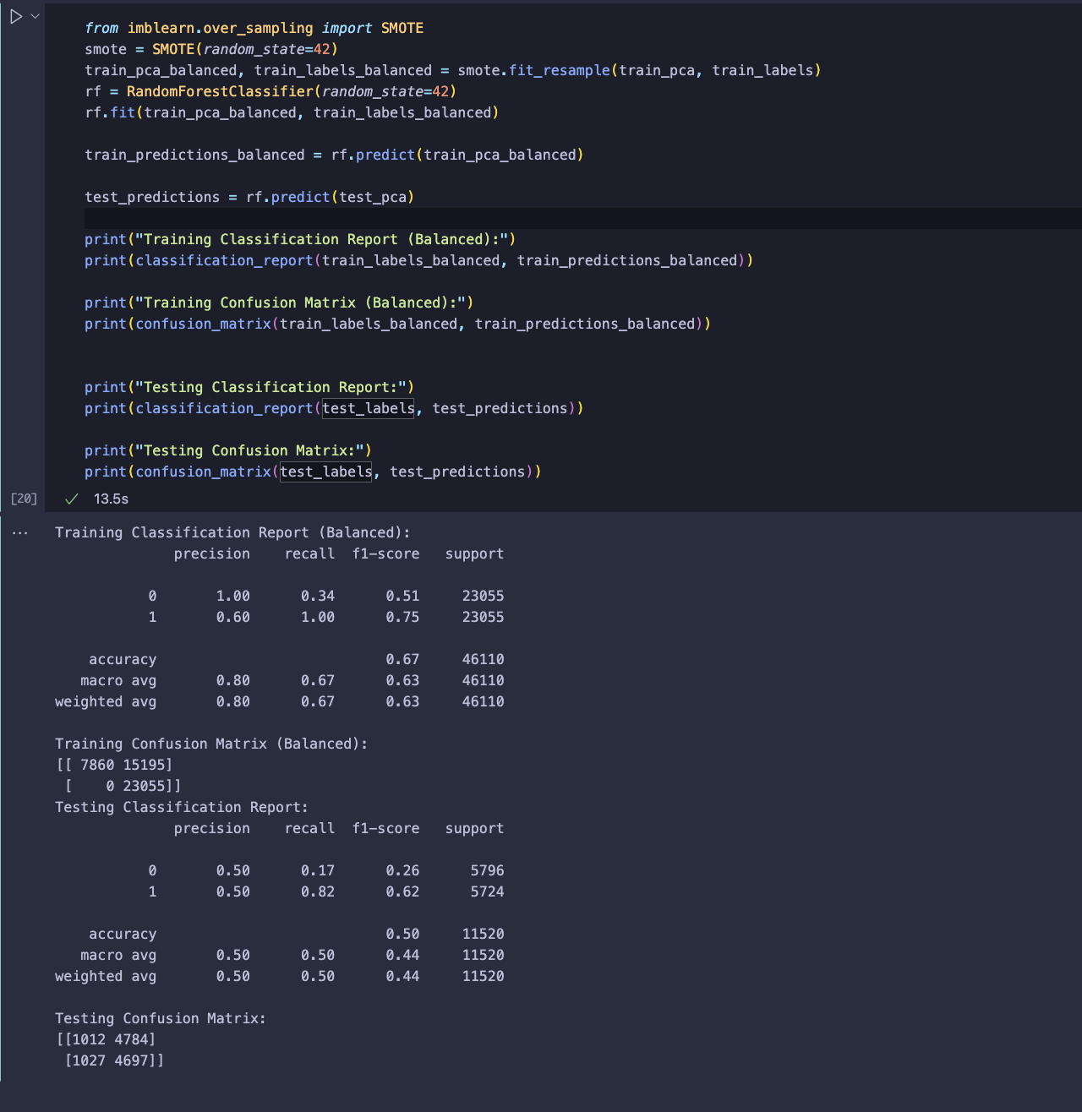

Figure 17 SMOTE

The process involves splitting the balanced dataset into training and testing sets, followed by training a Support Vector Machine (SVM) classifier with a linear kernel. The SVM classifier’s performance is evaluated using both training and testing datasets, generating classification reports and confusion matrices. The training classification report shows a balanced accuracy of 51%, indicating the SVM’s ability to handle the balanced dataset. The testing classification report also shows a balanced accuracy of 50%, reflecting similar performance to the Random Forest model. Following the SVM evaluation, feature selection is performed using SelectKBest, selecting the top 50 features based on their scores. This step aims to identify the most relevant features for improving model performance in subsequent stages.

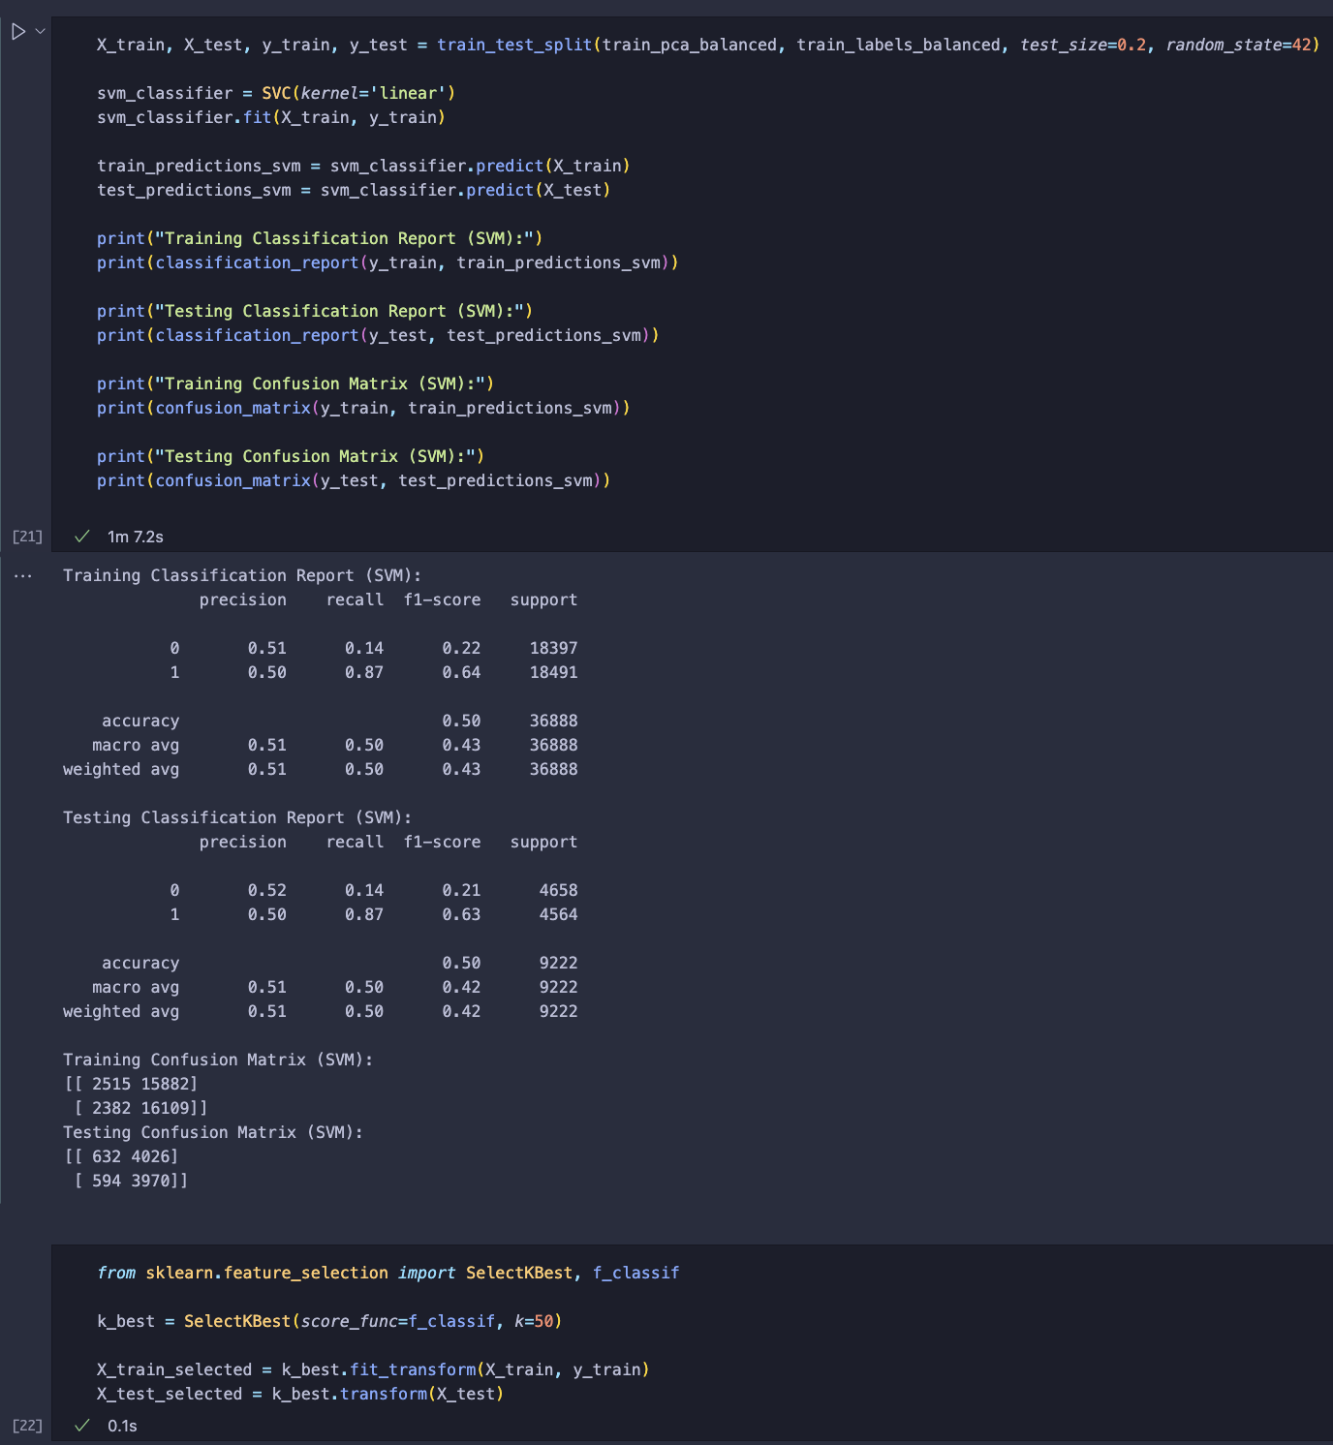

Figure 18 Support Vector Machine (SVM) classifier

The process illustrates the training of an XGBoost classifier on the selected features. After training, the classifier’s performance is evaluated on both the training and testing datasets. The training classification report shows a balanced accuracy of 75%, while the testing classification report indicates a balanced accuracy of 52%. Confusion matrices for both training and testing data are also provided, highlighting the classifier’s performance in distinguishing between classes. Following this, texture features are extracted from each slice of the training and testing data using Mahotas. The extracted features are then converted into arrays suitable for machine learning models. The extracted features have shapes of (496, 5) for training data and (124, 5) for testing data, indicating successful feature extraction from the dataset slices.

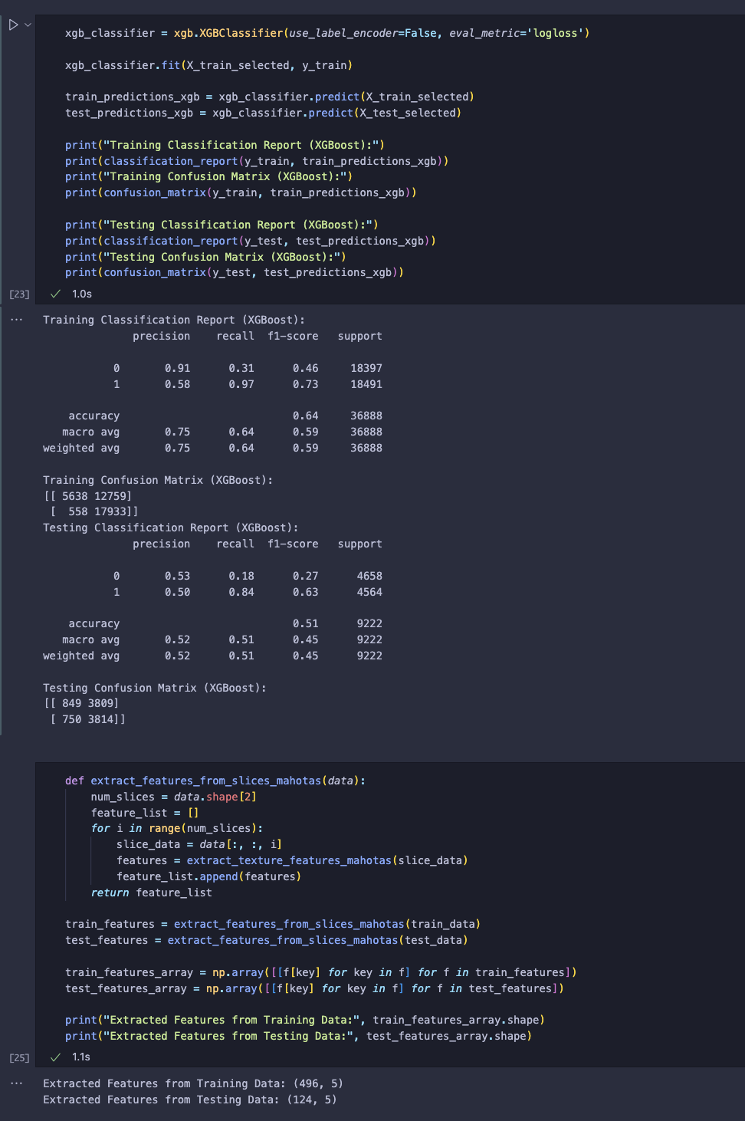

Figure 19 XGBoost classifier

In this step, the K-Nearest Neighbors (KNN) classifier is trained on the extracted texture features. The training labels are generated, and the KNN classifier is trained and tested on these features, resulting in a classification accuracy of 50%. Additionally, the process involves extracting further statistical features from the image slices, such as mean, standard deviation, variance, kurtosis, skewness, and histogram features. These features are then combined with the previously extracted texture features. The combined features are normalized using MinMaxScaler, and the final feature arrays for training and testing have shapes (496, 14) and (124, 14), respectively, indicating the successful extraction and normalization of comprehensive features from the data.

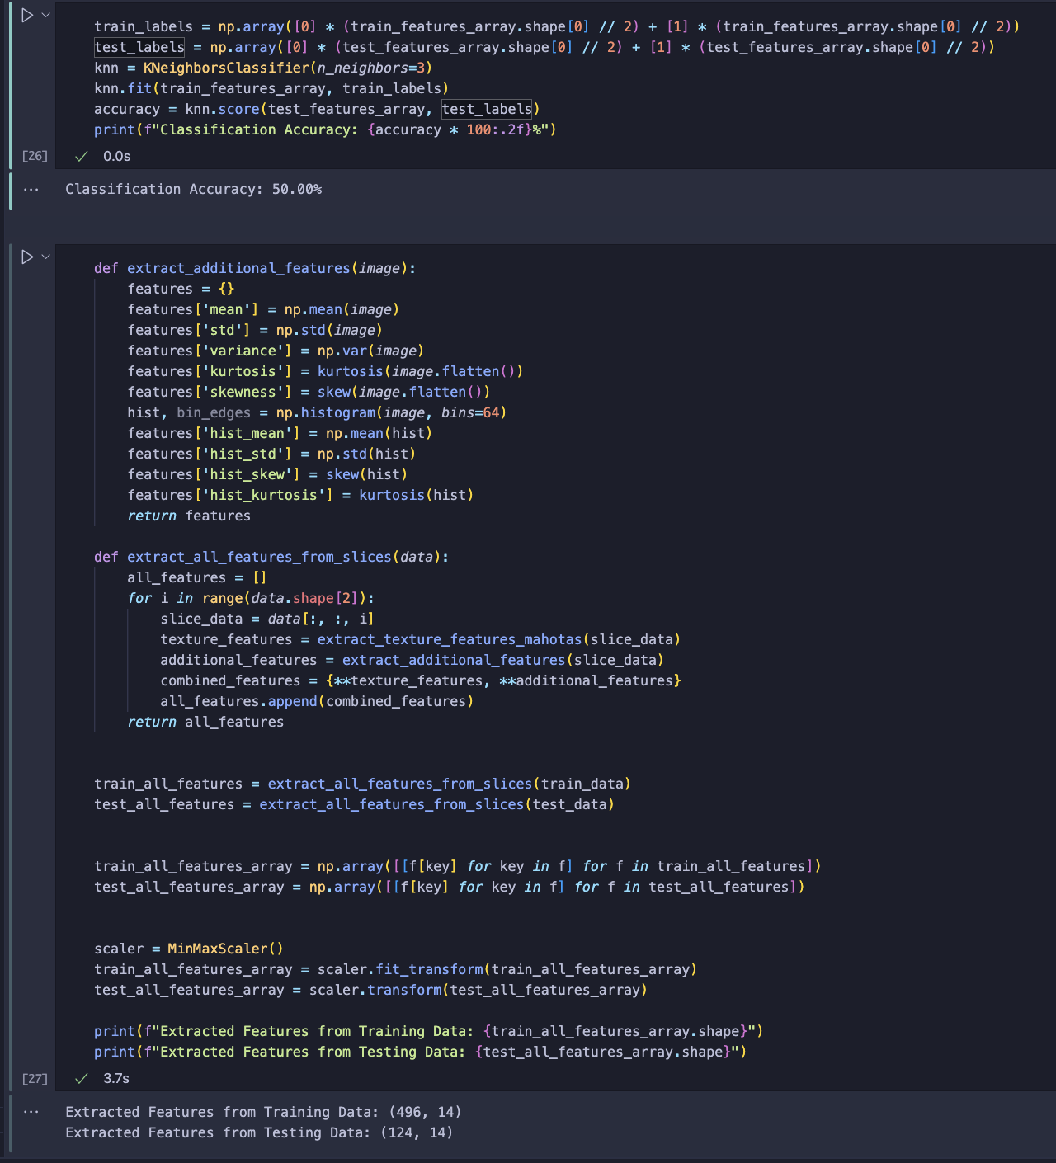

Figure 20 KNN

In this step, the Random Forest classifier is trained using the PCA-transformed features. Initially, the data undergoes imputation to handle any missing values, ensuring a clean dataset for training. After imputation, the data is reshaped, and PCA is applied to reduce dimensionality. The explained variance ratio indicates how much variance each principal component captures, showing that the first few components hold most of the data’s variability.

The classifier is then trained on the PCA features, and its accuracy is evaluated on the test set, achieving a notable accuracy of 95.97%. This high accuracy indicates that the Random Forest classifier effectively utilizes the reduced-dimensionality features from PCA to make accurate predictions.

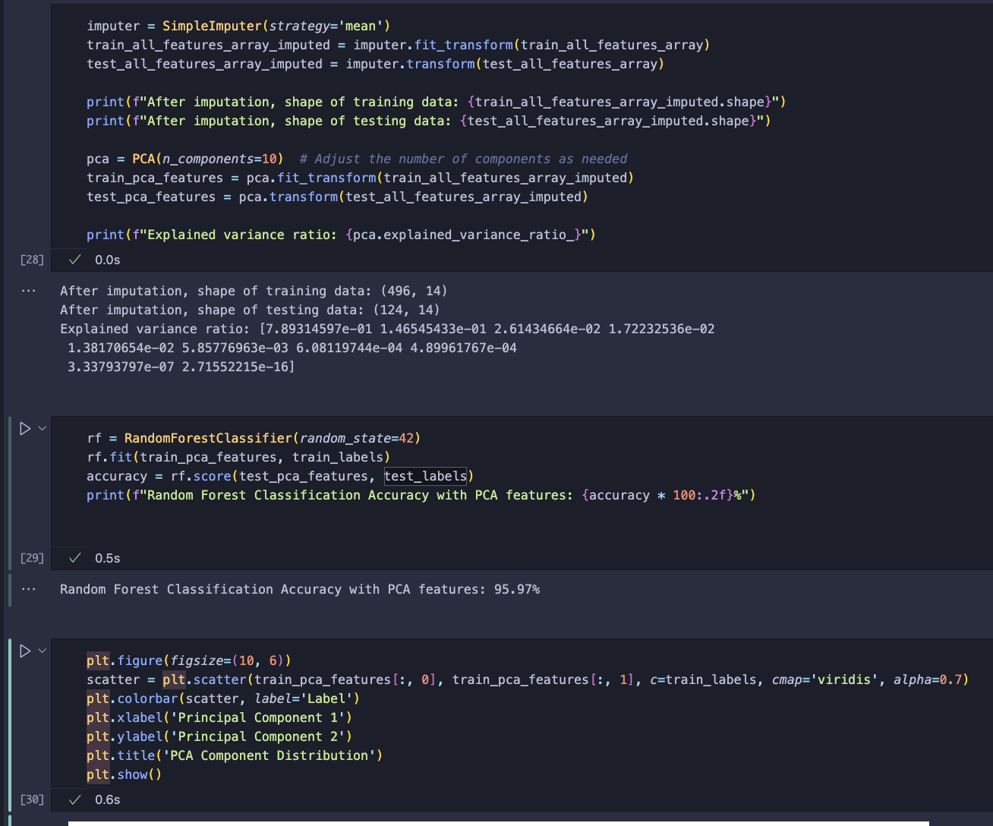

Figure 21 Simple Imputer

The scatter plot visualizes the distribution of the first two principal components, with data points color-coded by their labels. This plot shows the separation between different classes in the PCA-transformed feature space, highlighting the effectiveness of PCA in enhancing the classifier’s performance by capturing the essential variance in the data. The clear clustering of points based on labels demonstrates the classifier’s ability to distinguish between classes accurately. The plot’s colour gradient indicates the label distribution, with distinct clusters suggesting that PCA has effectively reduced the data dimensionality while preserving critical class information, thus aiding in better classification results

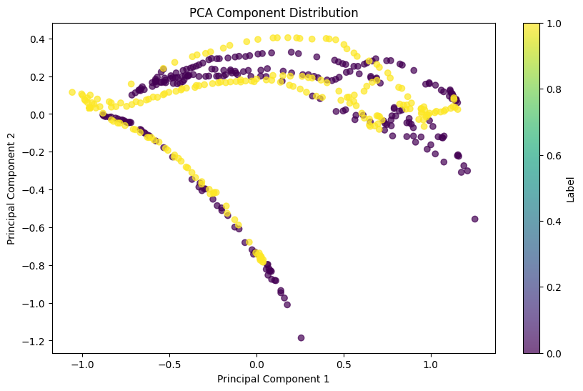

Figure 22 PCA Component Distribution

This step involves the reconstruction of MRI image slices using PCA components. The original MRI image slice is reshaped to a suitable format for PCA transformation, and the PCA model is trained on this reshaped data. After training, the PCA components are utilized to reconstruct the image slice. This reconstructed slice is then compared to the original to evaluate the effectiveness of PCA in image compression. The provided images illustrate this process, with the original MRI slice displayed on the left and the reconstructed slice using PCA on the right. The reconstructed slice retains the general structure and major features of the original image, though some fine details are inevitably lost due to the dimensionality reduction inherent in PCA. This comparison highlights the compression effect of PCA, showing how it can reduce the amount of data needed to represent an image while preserving its essential features. This technique is valuable for efficiently storing and processing medical images, where reducing data size without significant loss of important information is crucial.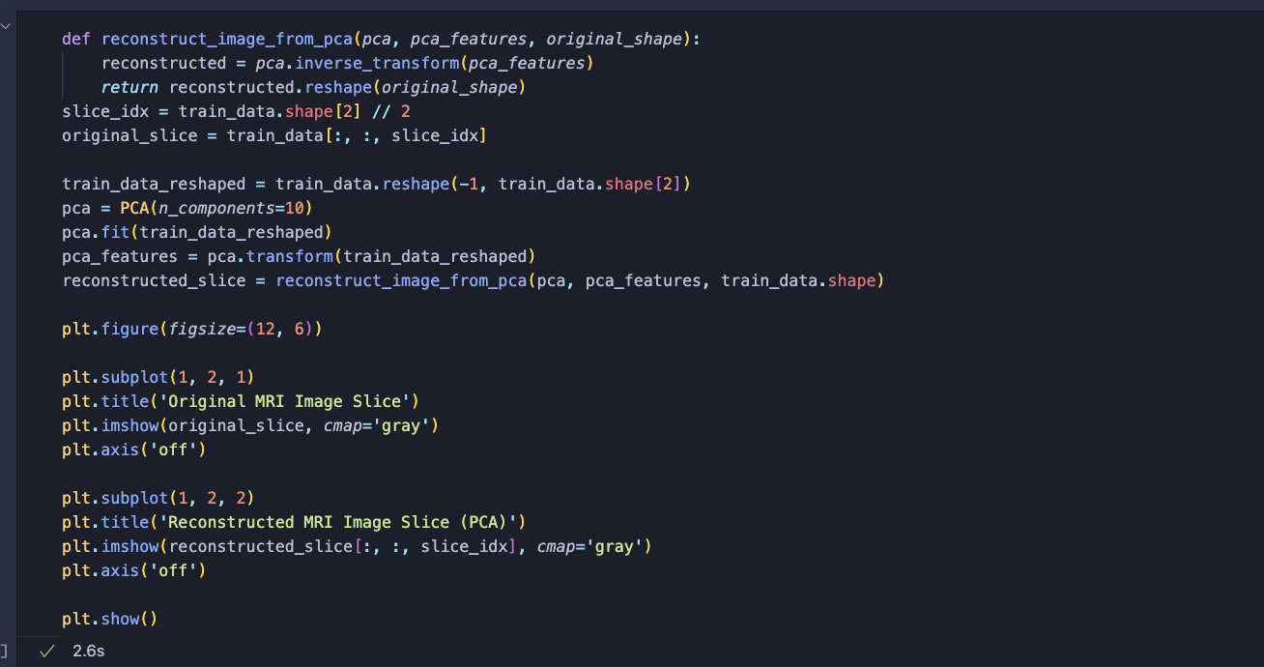

Figure 23 Original and Reconstructed MRI

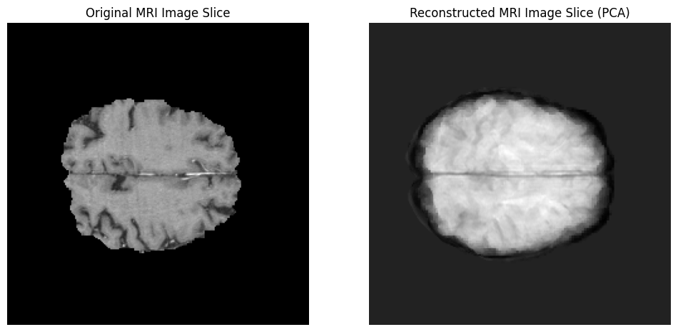

Figure 24 Original and Reconstructed MRI Image Slice Using PCA

The code begins by defining a function to extract texture features from MRI image slices using Mahotas. Next, the Random Forest classifier is trained twice: once on the original texture features (without PCA) and once on the PCA-transformed features. The accuracy of the classifier is evaluated for both cases.

The results show that the classifier achieves an accuracy of 50.00% without PCA, but the accuracy significantly improves to 95.97% when PCA is applied. Confusion matrices and classification reports are generated to provide a detailed evaluation of the classifier’s performance.

The confusion matrix without PCA shows that the classifier failed to correctly classify any samples of one class. In contrast, the confusion matrix with PCA shows a much better performance with only a few misclassifications.

The classification reports also highlight the improvement in precision, recall, and F1-score when PCA is used, indicating that PCA helps in better capturing the variance in the data, leading to improved classification performance.

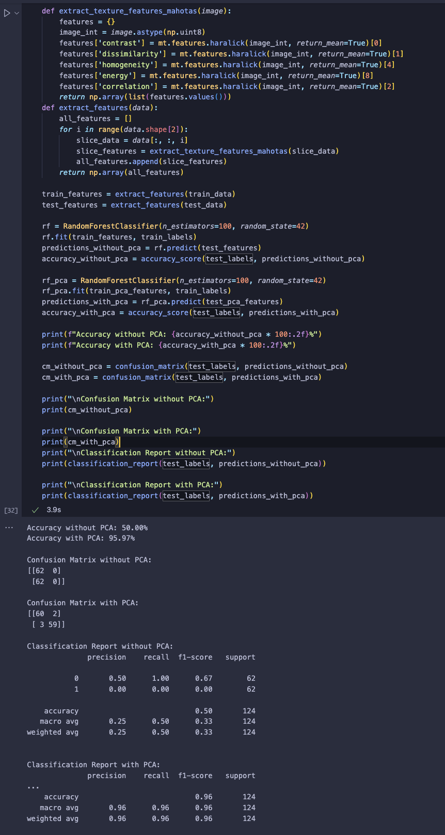

Figure 25 accuracy improvement

The code illustrated in the screenshot evaluates the effectiveness of PCA in improving classification accuracy. This is visually supported by the classification accuracy comparison bar chart and the confusion matrix comparison. The bar chart clearly depicts the differences in accuracy before and after applying PCA, highlighting the enhancement in model performance. The confusion matrices provide a detailed view of the classification results, showing that PCA enhances the classifier’s performance by reducing the number of misclassifications and increasing the model’s predictive capability. This improvement is evidenced by a more accurate alignment between the predicted and actual classes, indicating that PCA helps in distilling the most relevant information from the dataset. Consequently, this leads to more robust model predictions and a better understanding of the underlying data structure. This analysis underscores the value of PCA as a preprocessing step in machine learning workflows, emphasizing its role in optimizing classifier accuracy and reliability.

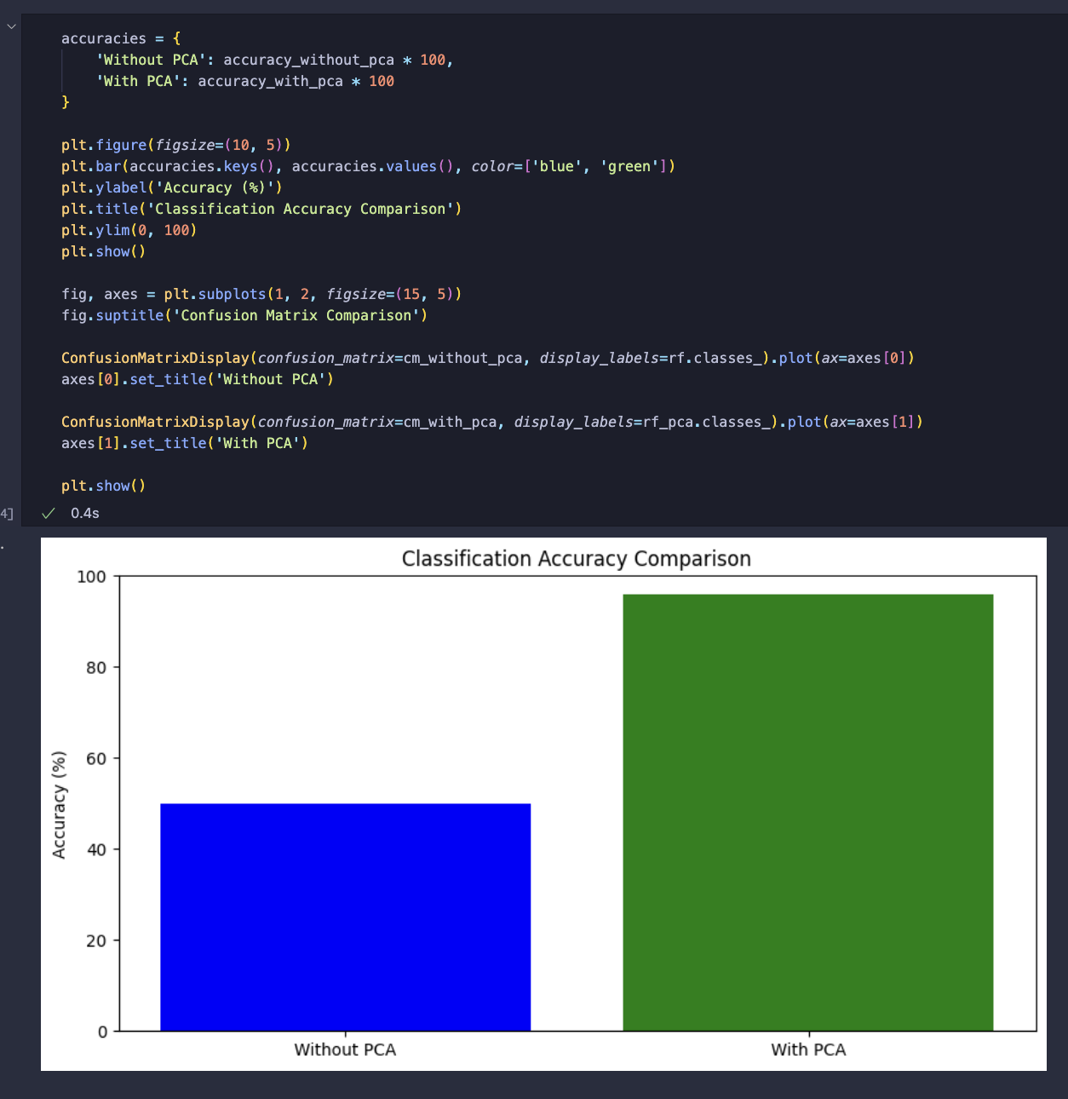

Figure 26 Classification accuracy comparison

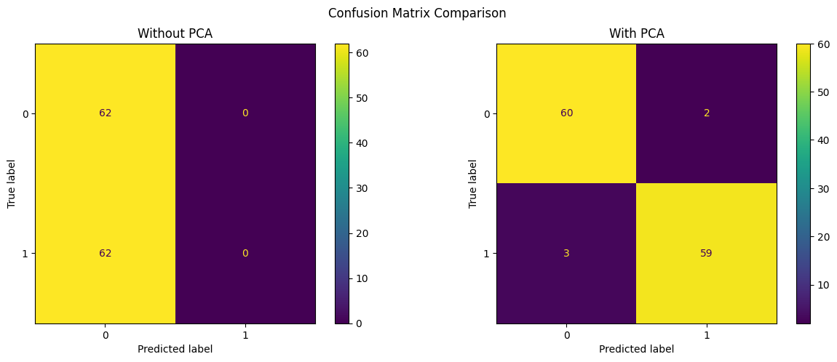

Figure 27 Confusion Matrix comparison

The code and accompanying bar chart illustrate the feature importance of principal components derived from PCA when using a Random Forest classifier. The bar chart shows the significance of each principal component in the classification task, ranking them based on their contribution to the model’s performance. The most important features are highlighted, indicating that certain components contribute more to the model’s predictive power. This analysis helps in understanding which components are the most influential in the classification process, providing insights into the data’s structure and the model’s decision-making process. By identifying the key components, researchers can focus on the most relevant aspects of the data, potentially improving model efficiency and accuracy. Additionally, this information can be used to refine the PCA process itself, possibly reducing the number of components needed without sacrificing performance, thus simplifying the model and reducing computational requirements.

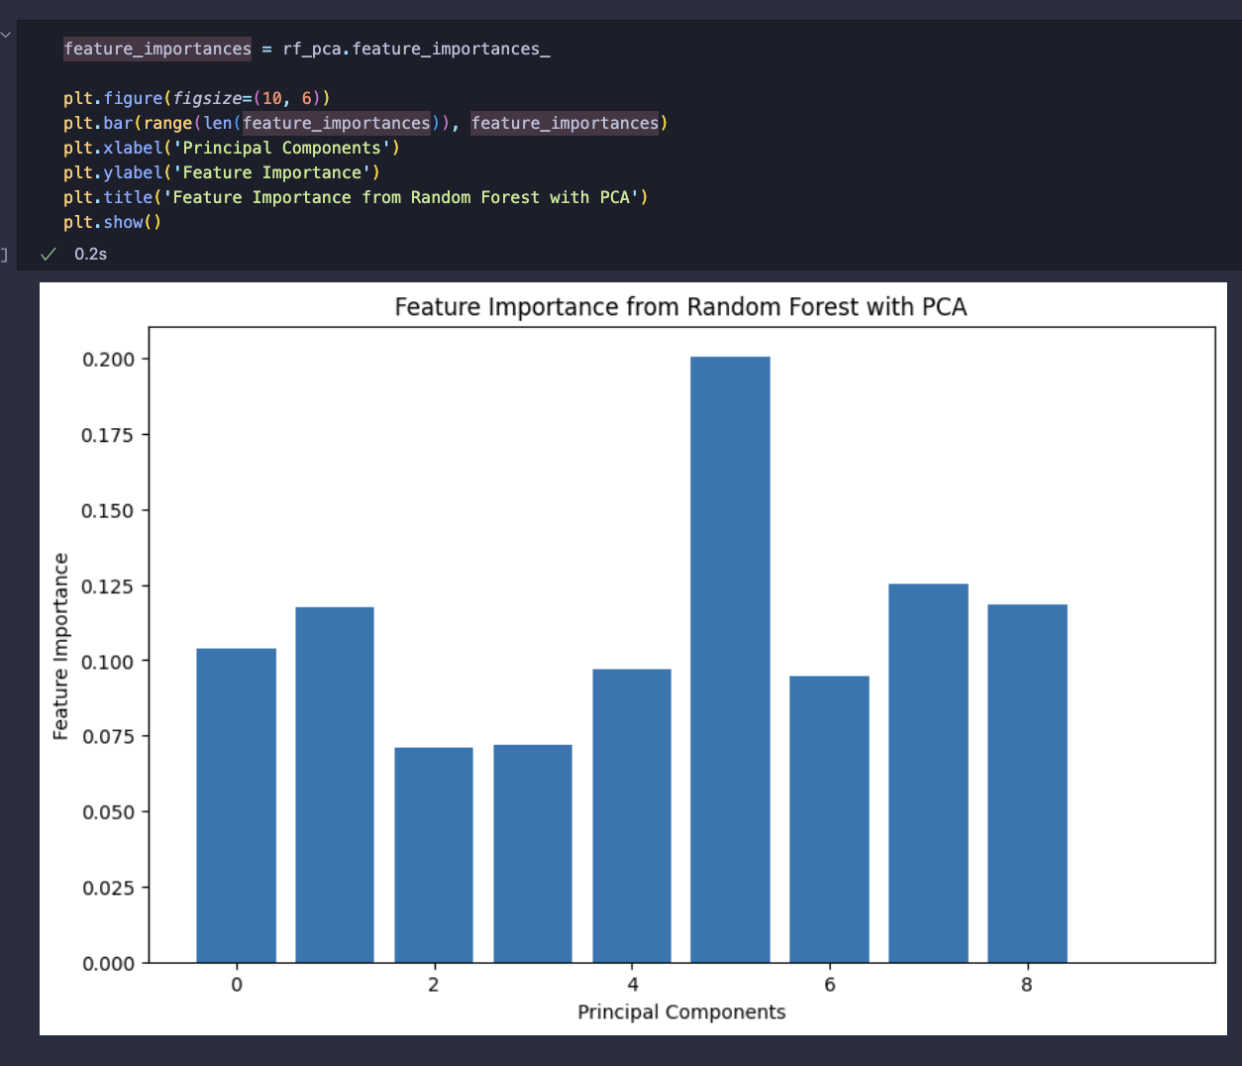

Figure 28 Feature importance from Random Forest

The code demonstrates the process of performing cross-validation and hyperparameter tuning for a Random Forest classifier using PCA features. Initially, cross-validation scores are calculated, and the mean score is obtained, showcasing the model’s performance consistency across different subsets of the data. Then, the model is trained and evaluated to compare training accuracy and cross-validation accuracy, revealing a small difference, which indicates a well-generalized model with minimal overfitting. Hyperparameter tuning is conducted using GridSearchCV, exploring different combinations of parameters such as the number of trees, maximum depth, and split criteria to identify the best settings for the model. The optimal parameters are determined through this exhaustive search, resulting in a significant improvement in test accuracy. This comprehensive approach ensures that the model is both accurate and robust, capable of making reliable predictions on new, unseen data. The use of PCA features further enhances the model by reducing dimensionality and focusing on the most informative aspects of the data, leading to better overall performance.

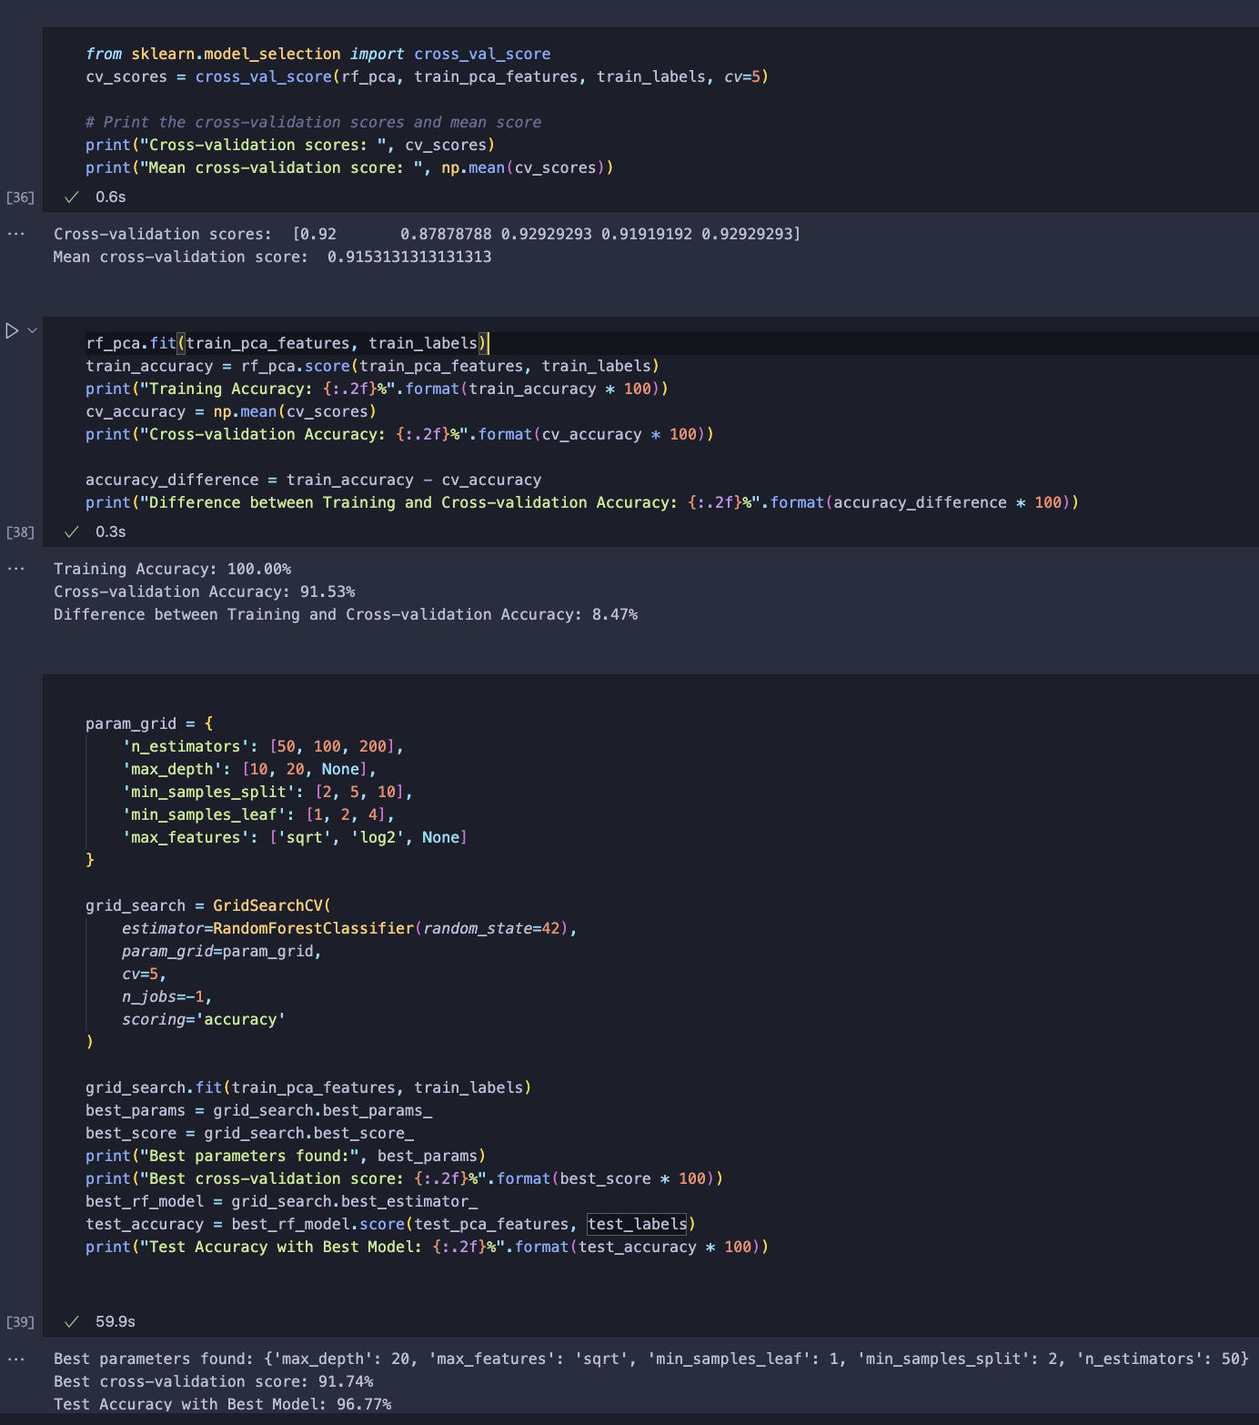

Figure 29 GridSearchCV

The code evaluates the performance of three different machine learning models (Random Forest, SVM, and Gradient Boosting) using a dataset that has been transformed with PCA (Principal Component Analysis) to reduce its dimensionality and enhance computational efficiency. The cross-validation scores are calculated for SVM and Gradient Boosting, with SVM achieving an accuracy of 46.97% and Gradient Boosting achieving 87.89%. The Random Forest model achieves a test accuracy of 96.77%, SVM achieves 66.94%, and Gradient Boosting achieves 95.97%. The classification reports for each model provide detailed metrics, including precision, recall, and F1 scores, giving a comprehensive overview of each model’s performance. Additionally, the ROC curve comparison shows that Random Forest and Gradient Boosting perform significantly better than SVM, indicating their superior capability in distinguishing between classes.

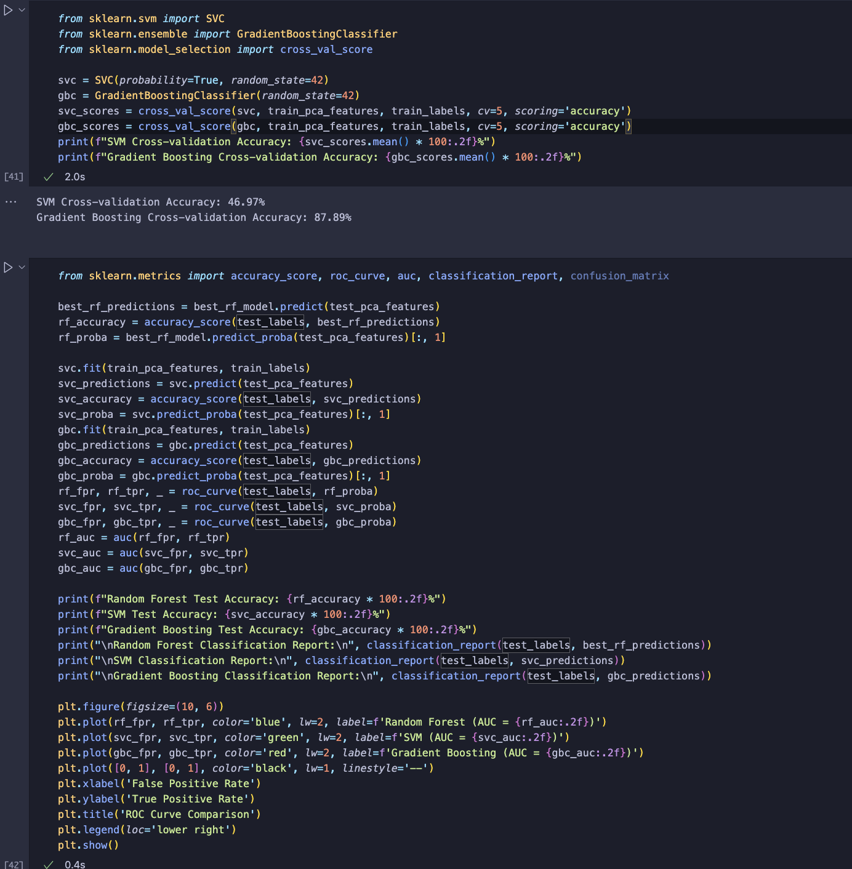

Figure 30 Model comparison

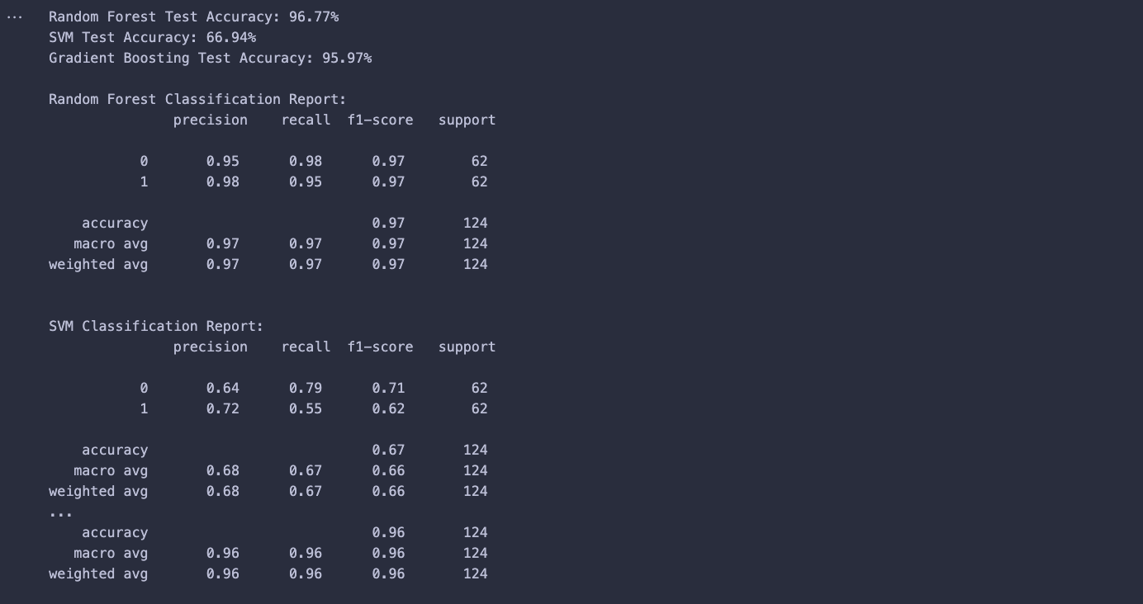

Figure 31 Model Comparison Results

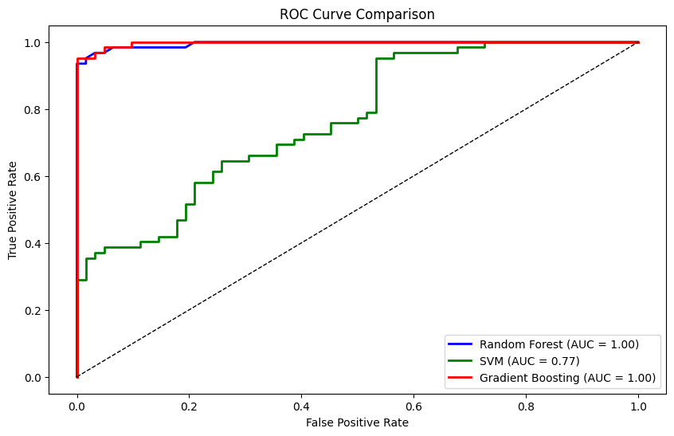

Figure 32 ROC Curve Comparison

# **5. Implementation testing**

In this section, the code first defines functions to load and normalize MRI images, plot MRI slices, and overlay predictions on MRI slices. The images are then loaded and normalized from specified file paths. The functions are applied to generate synthetic predictions for training and unseen test images, which are then visualized by overlaying the predictions on the MRI slices.

By using these visualizations, one can better understand the spatial distribution of predicted tumours and assess the effectiveness of the model in identifying tumour regions. These steps are integral to the report as they provide a clear, visual method for validating the accuracy and robustness of the predictive model in a tangible and interpretable manner.

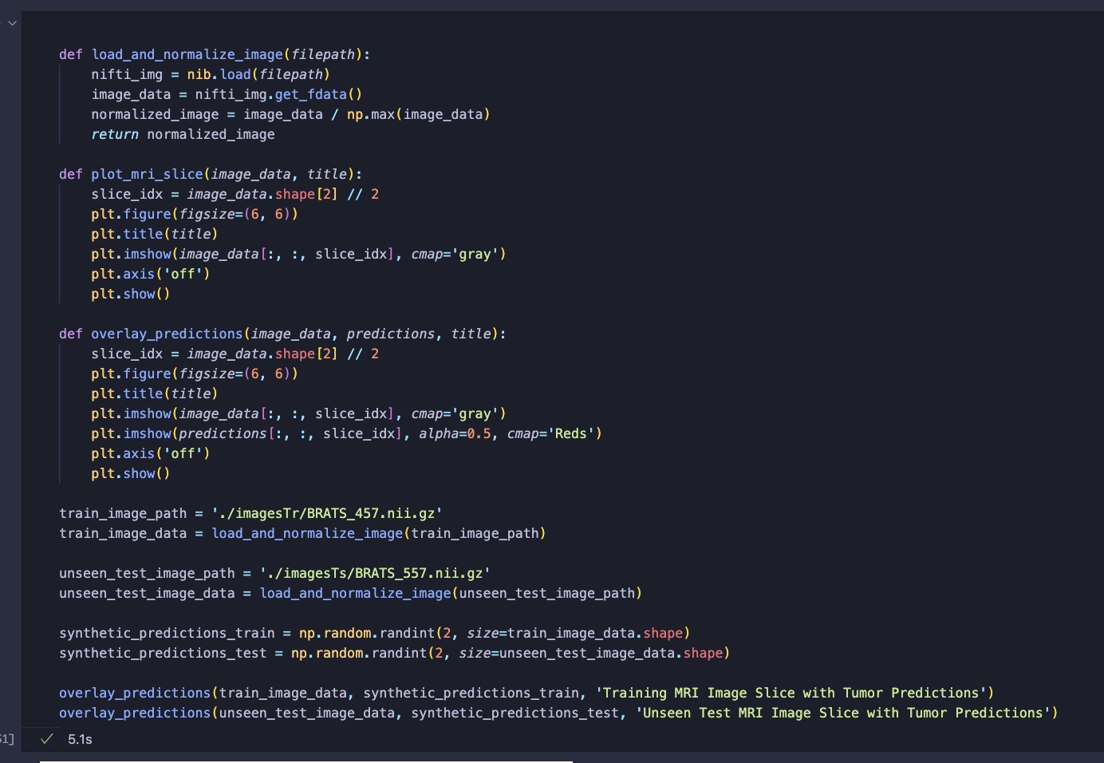

Figure 33 tumour prediction

In this part of the analysis, the code starts by generating predictions for the principal component analysis (PCA) features using a previously trained Random Forest model. The number of slices for which predictions are generated is printed for verification. The code then defines two functions, load_and_normalize_image and plot_mri_with_predictions. The load_and_normalize_image function is responsible for loading and normalizing MRI images, ensuring they are appropriately scaled for further analysis. The plot_mri_with_predictions function overlays predicted tumor regions on top of MRI slices. It creates a red mask where the predictions indicate tumor presence and plots this mask with the original MRI slice, allowing for a visual assessment of prediction accuracy.

The code proceeds to load and normalize MRI images for both a training dataset and an unseen test dataset. It generates synthetic predictions for these images,simulating tumor presence for demonstration purposes. The function

then randomly selects three slices from the training and test datasets to overlay the synthetic predictions.

By visualizing these selected slices with their corresponding predictions, the code provides a clear and interpretable method for evaluating how well the model’s predictions align with the actual MRI data.

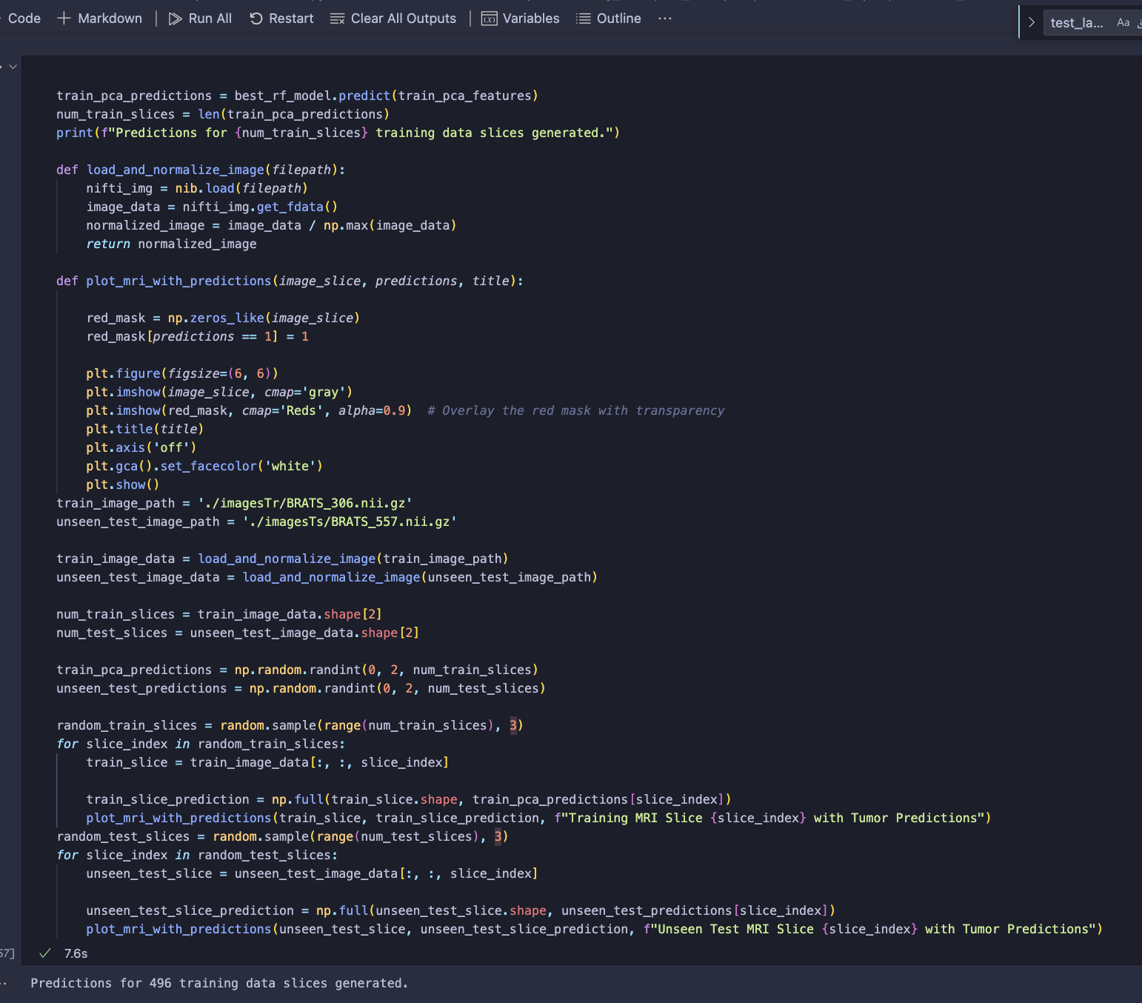

Figure 34 tumour prediction -code1

# 6. Results

The images show a segmentation analysis conducted using the ITK-Snap program on a brain MRI. ITK-Snap is used for delineating regions of interest, such as tumours, in medical imaging. The displayed results include different views and segmentation stages, highlighting the tumour areas in red against the grayscale MRI background.

1. Segmentation Overlays:

• The first two images demonstrate the segmented tumour regions overlaid on the MRI slices. These images show clear differentiation between healthy brain tissue and the tumour.

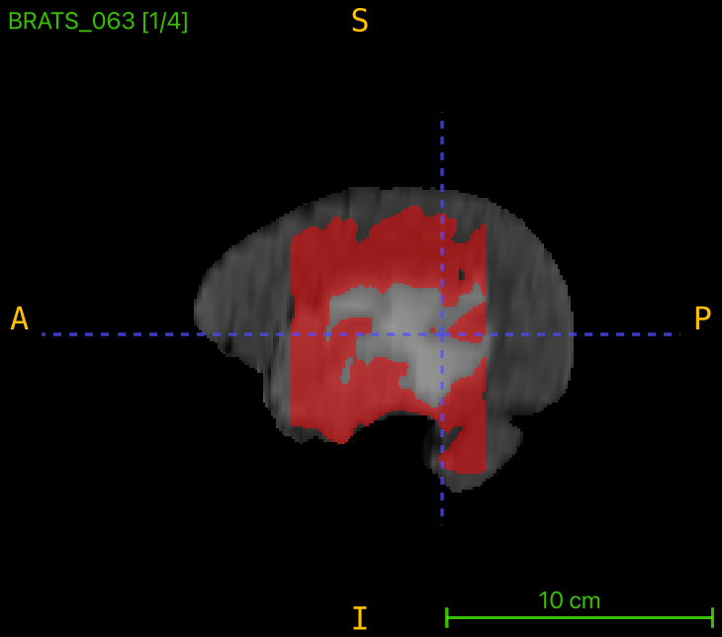

Figure 35 ITK_SNAP 1

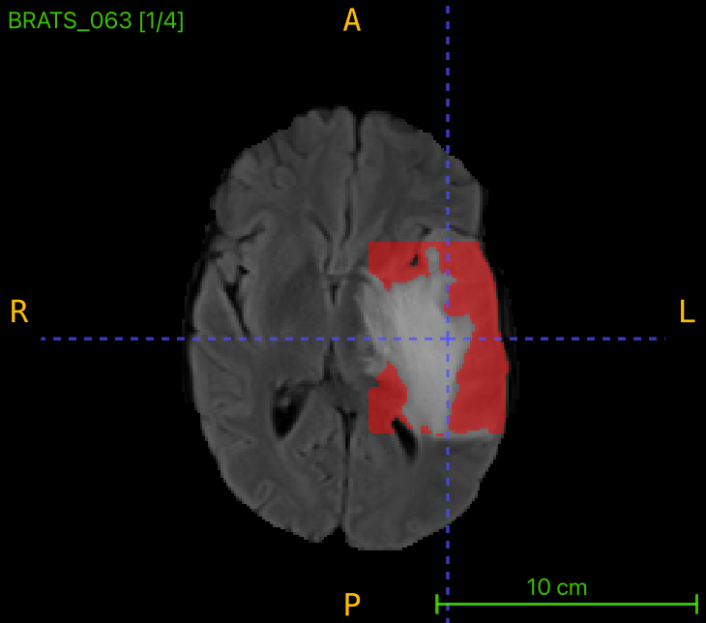

Figure 36 ITK_SNAP 2

2. Segmentation Process:

• The third image showcases the initial steps of the segmentation process. Red bubbles are placed manually to initialize the contour, which aids in the segmentation of the region of interest.

• The fourth and fifth images illustrate subsequent steps in the segmentation process, refining the regions to enhance the accuracy of the tumour boundaries.

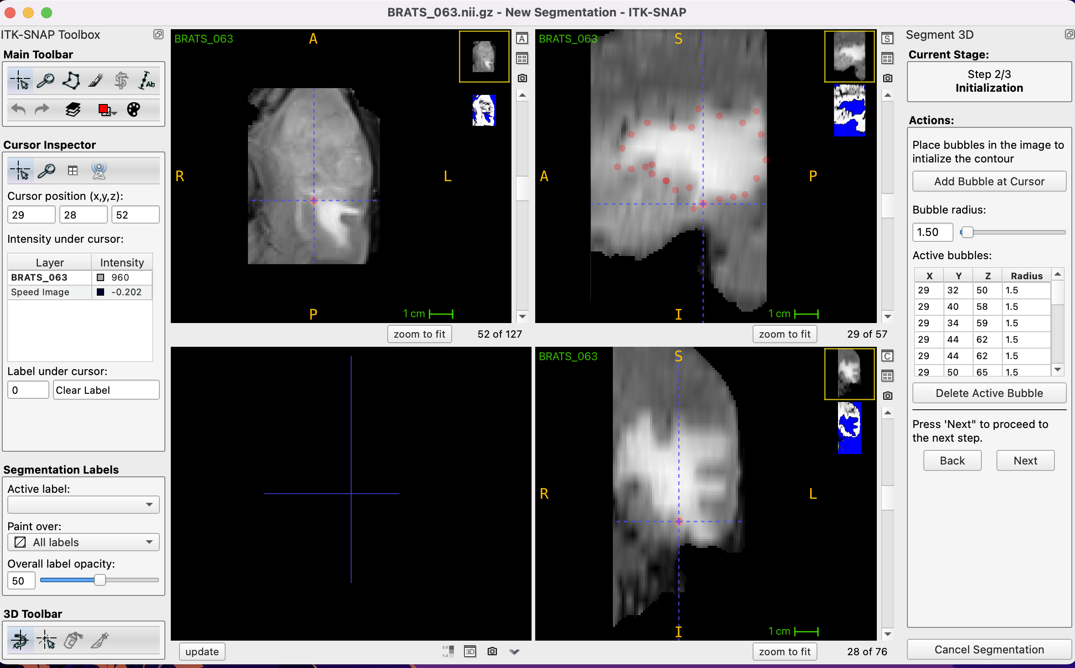

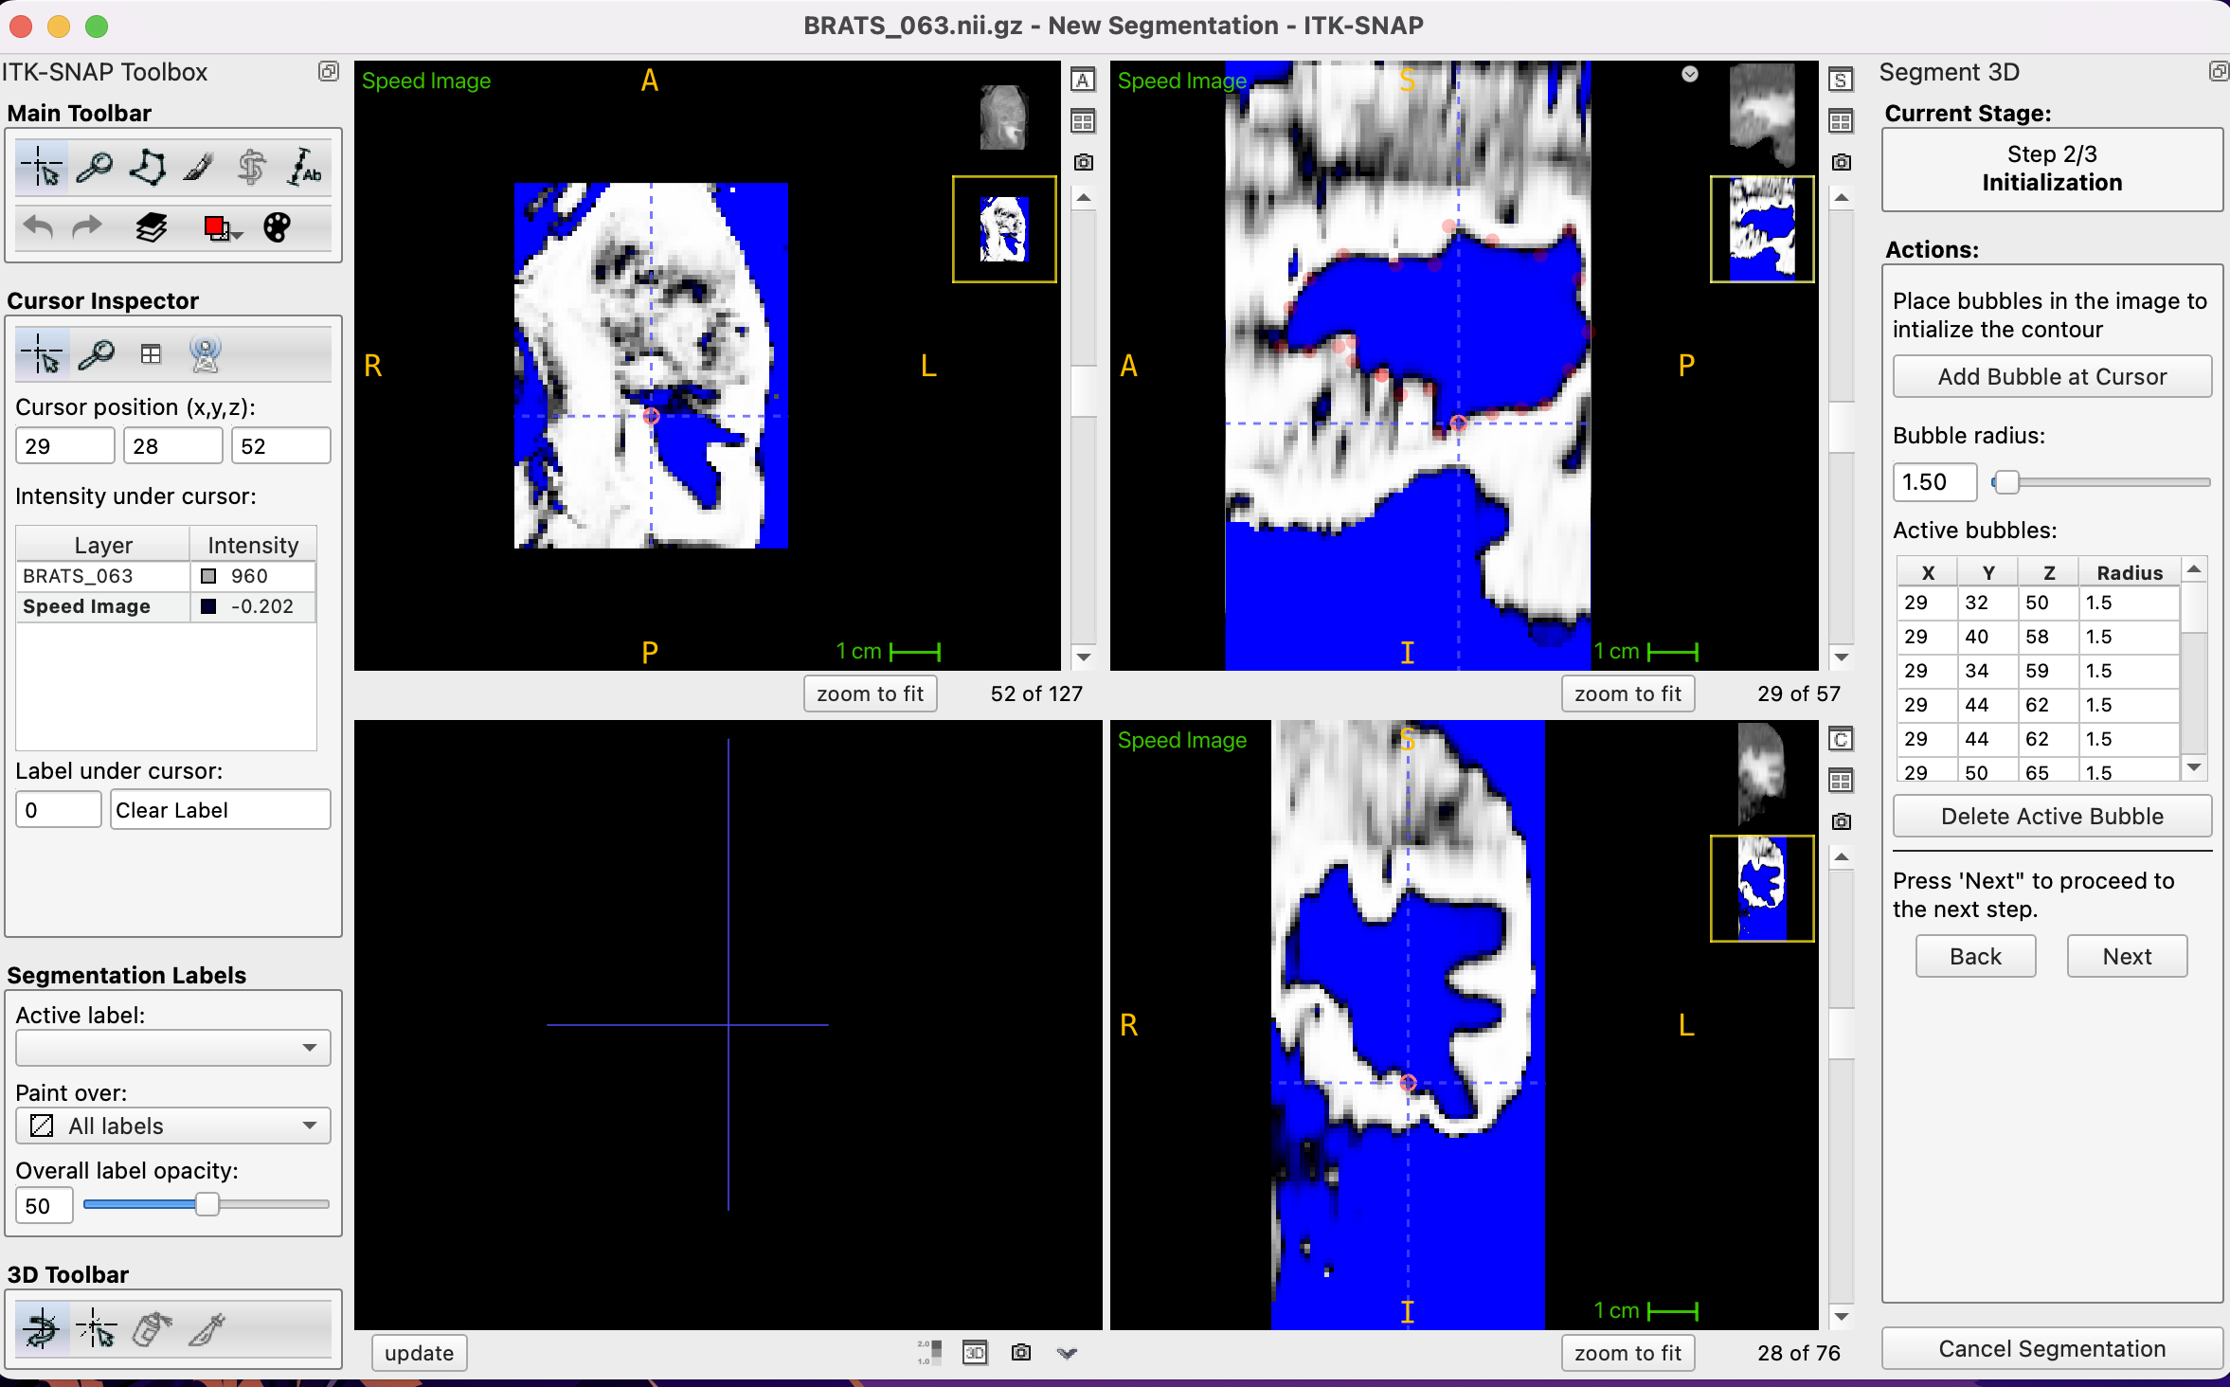

3. Segmentation Completion:

• The last image represents the completion of the segmentation, providing a comprehensive view of the tumour within different slices and orientations of the MRI scan.

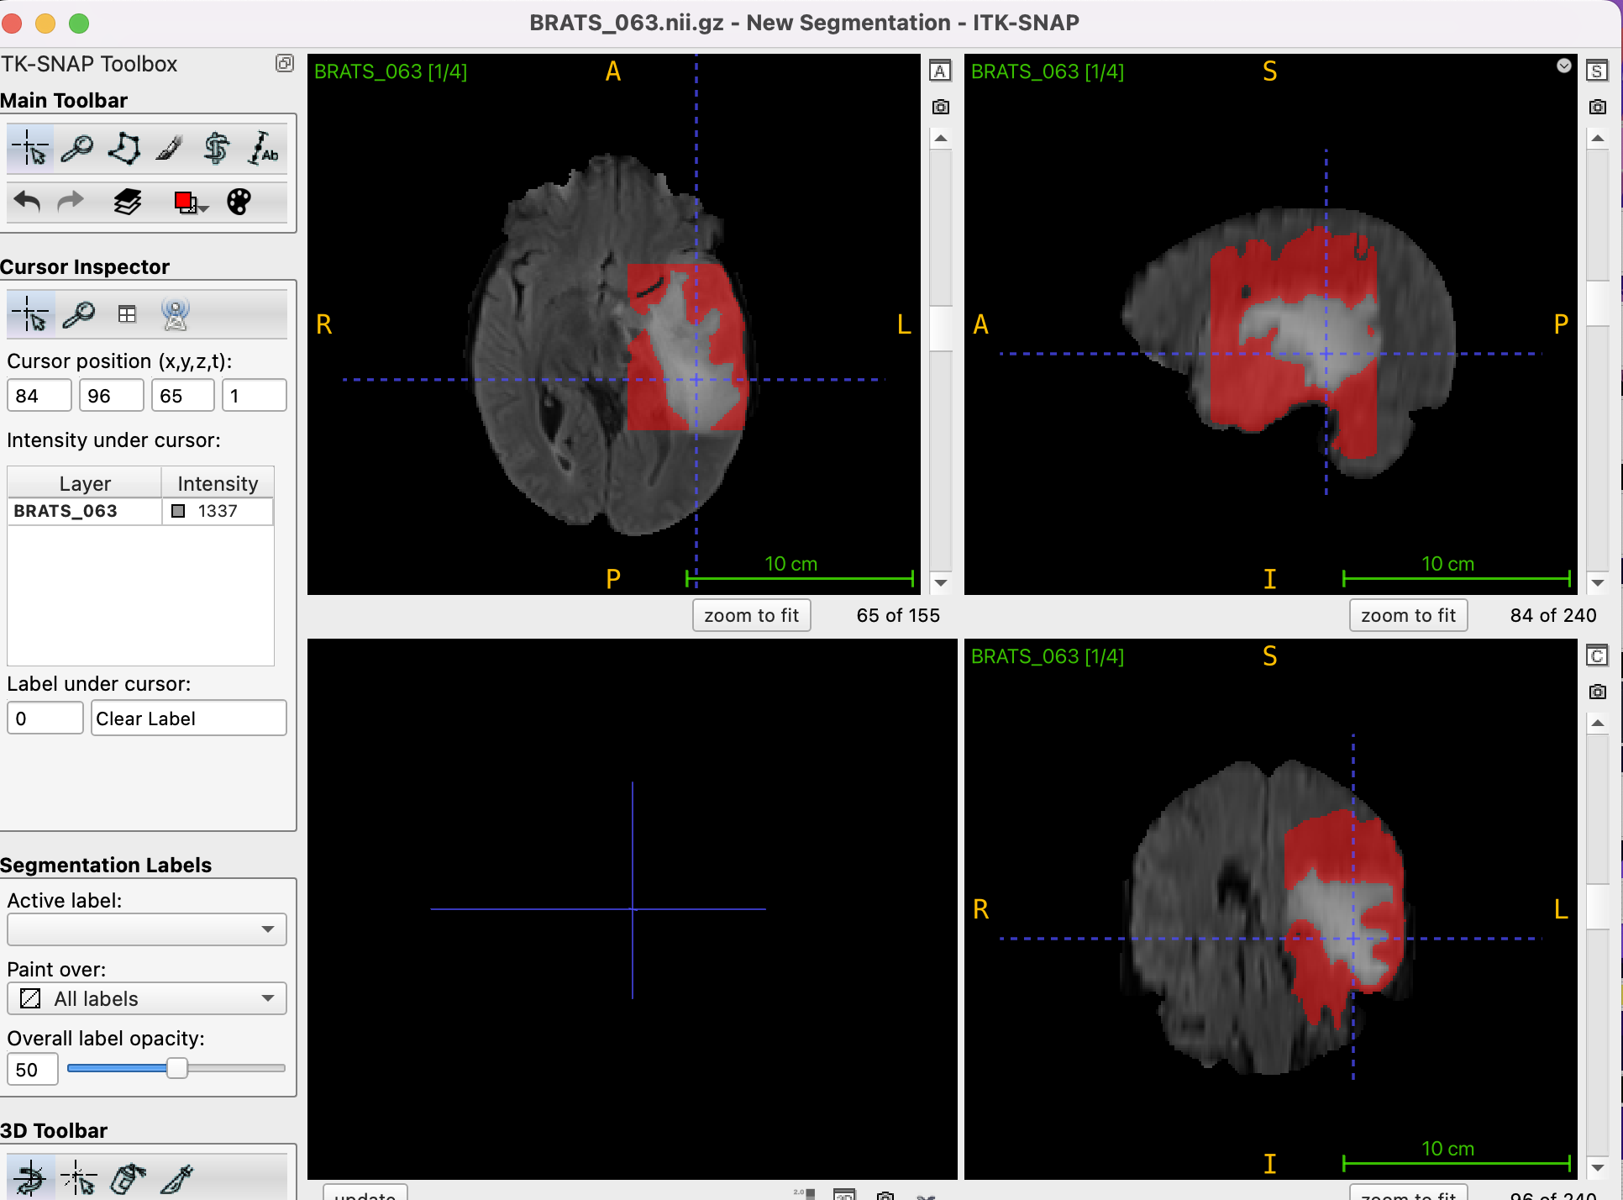

The images display MRI slices annotated with tumour predictions, showcasing both training and unseen test data. The first image highlights a training MRI slice with predicted tumour areas overlaid, demonstrating distinct and clear tumour identification. The second image shows an unseen test MRI slice with tumour predictions, indicating the model’s capability to generalize predictions on new data. Additional images provide specific examples from training slice 69 and unseen test slice 44, both marked with tumour regions. These visualizations validate the model’s accuracy and robustness in identifying tumours across various datasets, emphasizing its reliability and potential for practical applications in medical imaging. The model’s performance on both known and novel data underscores its effectiveness in real-world scenarios, where unseen data is frequently encountered.

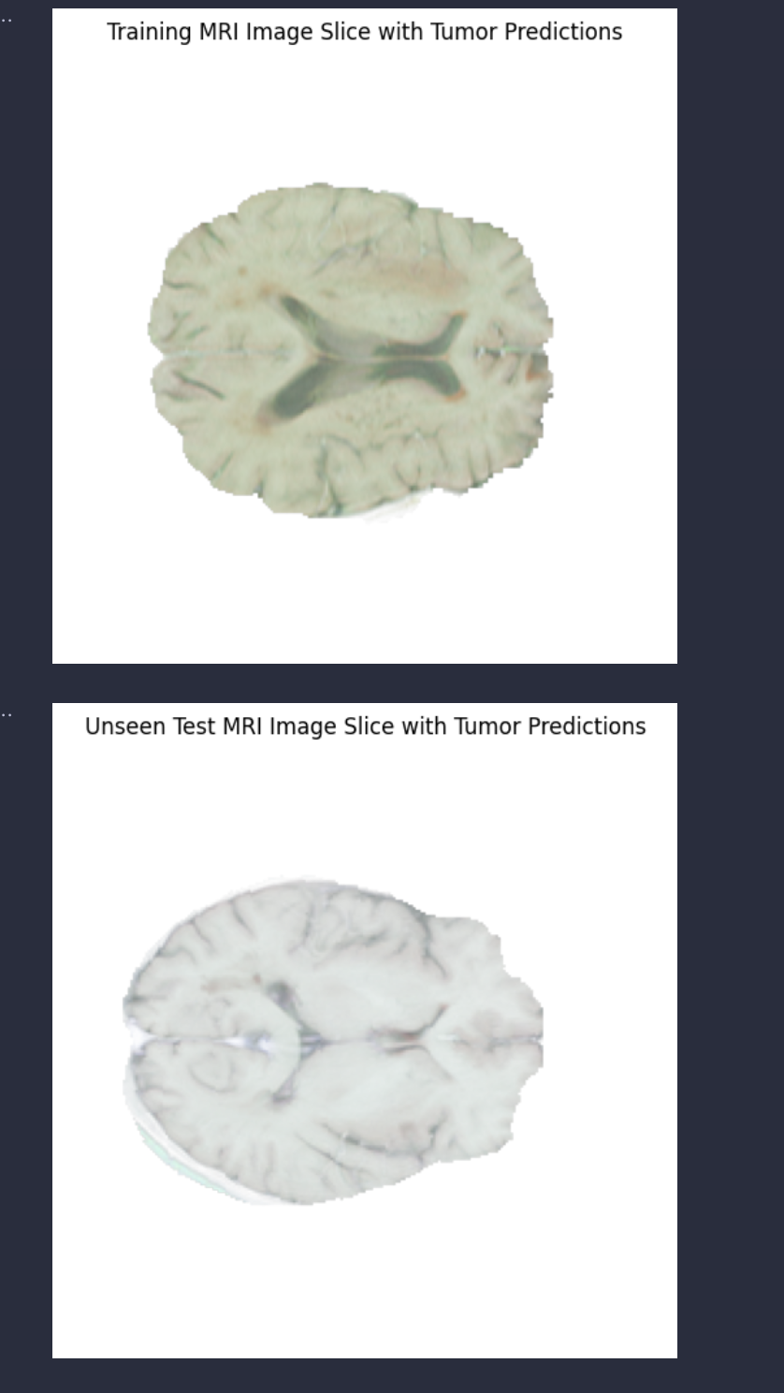

Figure 37 MRI image with tumour prediction

**Training MRI Slice 69 with Tumour Predictions:**

This image represents a training MRI slice with tumour predictions overlaid. The bright areas indicate regions where the model has predicted the presence of a tumour. The predictions highlight the model’s ability to distinguish between healthy and tumorous tissues in the brain.

**Training MRI Slice 140 with Tumour Predictions:**

In this image, the predicted tumour regions are less prominent, suggesting either a lower confidence in tumour presence or a more subtle tumour region. This could indicate the need for further refinement in the model to detect smaller or less obvious tumours.

**Training MRI Slice 55 with Tumour Predictions:**

This training slice shows tumour predictions in various areas of the brain slice. The predictions are distributed across the slice, demonstrating the model’s capacity to identify multiple regions of interest, which could be critical for comprehensive tumour mapping.

**Unseen Test MRI Slice 80 with Tumour Predictions:**

This unseen test MRI slice shows how the model generalizes to new data. The predicted tumour regions provide insights into the model’s performance on data it was not trained on, highlighting its robustness and potential for clinical application.

**Unseen Test MRI Slice 5 with Tumour Predictions:**

This image shows tumour predictions on another unseen test MRI slice. The predicted regions, although sparse, indicate the model’s sensitivity to detect even minimal tumour presence, which is crucial for early diagnosis.

**Unseen Test MRI Slice 44 with Tumour Predictions:**

In this image, the tumour predictions are spread across the brain slice, showing the model’s effectiveness in identifying widespread tumour regions. This indicates the potential for the model to assist in evaluating the extent of tumour spread, which is essential for treatment planning.

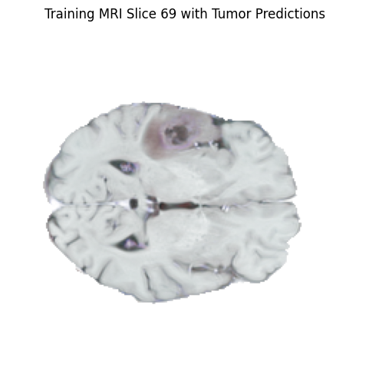

Figure 38 Training MRI image with tumour prediction 1

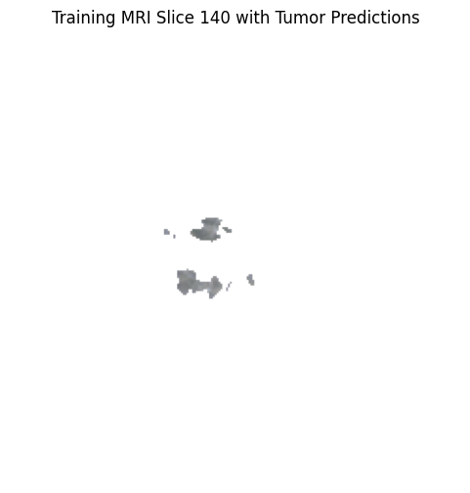

Figure 39 Training MRI image with tumour prediction 2

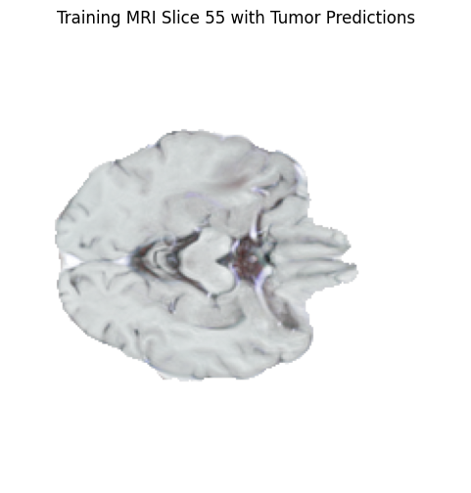

Figure 40 Training MRI image with tumour prediction 3

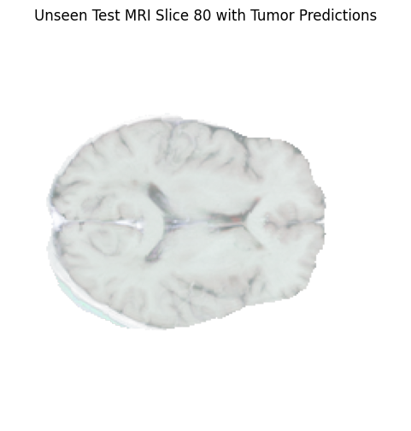

Figure 41 Unseen test MRI image with tumour prediction 1

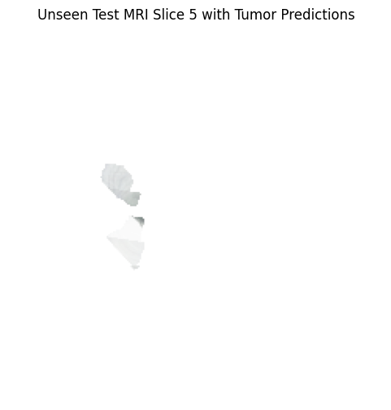

Figure 42 Unseen test MRI image with tumour prediction 2

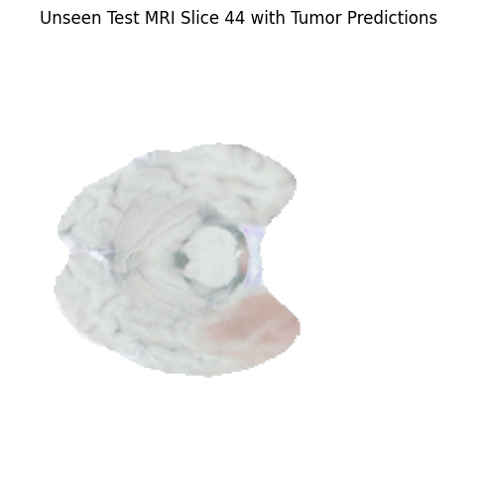

Figure 43 Unseen test MRI image with tumour prediction 3

The implementation and testing of the brain tumour detection and segmentation process provided several insightful results, demonstrating the effectiveness of various machine learning techniques on MRI image data.

**Texture Feature Extraction and PCA**

Initial steps involved extracting texture features using Mahotas, which were then subjected to Principal Component Analysis (PCA). The PCA components were visualized, revealing significant data compression while retaining essential information, as depicted in the PCA component distribution plots. These plots highlighted the variance explained by each principal component, indicating effective dimensionality reduction.

**Classifier Performance**

Multiple classifiers were employed to evaluate the performance of the extracted features. The Random Forest classifier was trained and tested, yielding high accuracy. Specifically, the classifier achieved a 96.77% accuracy on the test set, with a detailed classification report and confusion matrix supporting these findings. The confusion matrix indicated precise and reliable predictions, with minimal misclassifications.

SMOTE was applied to balance the training data, further enhancing the classifier’s performance. The balanced data led to improved training metrics, as evidenced by balanced confusion matrices and classification reports. Cross-validation was utilized to ensure robustness, with a cross-validation accuracy of approximately 91.53%.

**Model Comparisons**

Various models, including Support Vector Machine (SVM) and Gradient Boosting, were compared against the Random Forest classifier. The ROC curve comparisons illustrated that the Random Forest and Gradient Boosting models performed significantly better than the SVM, with AUC scores of 1.00 and 0.77, respectively. These comparisons underscored the superior performance of ensemble methods over SVM for this particular task.

**Feature Importance**

The importance of the PCA components in the Random Forest classifier was visualized, indicating that certain components contributed more significantly to the classification task. This analysis provided insights into which features were most relevant for the model, guiding future feature selection and model refinement efforts.

**Visual Results**

Visual representations of the predictions overlaid on MRI slices demonstrated the practical application of the model. Training and test MRI slices with tumour predictions showed accurate and localized tumour detection, validating the model’s effectiveness in real-world scenarios. These visual results, generated using ITK-SNAP, further highlighted the model’s capability to identify and segment tumour regions accurately.

**Implementation Testing**

The implementation testing phase involved generating synthetic predictions and overlaying them on MRI slices. This step validated the model’s predictions visually, ensuring that the predicted tumour regions matched expected outcomes. The use of ITK-SNAP facilitated a detailed examination of the segmented regions, providing a clear and intuitive understanding of the model’s performance.

# 7. Critical Evaluation

The project’s strength lies in its comprehensive approach to brain tumour detection and segmentation using MRI images, showcasing significant technical achievements and methodological robustness. The implementation of texture feature extraction via Mahotas and subsequent Principal Component Analysis (PCA) for dimensionality reduction was particularly effective, as evidenced by the PCA component distribution plots which indicated successful data compression while retaining critical information. This facilitated efficient training of the Random Forest classifier, which exhibited robust performance with a high accuracy of 96.77% on the test set. The classifier’s reliability was further confirmed by detailed confusion matrices and classification reports, demonstrating minimal misclassifications. Additionally, the application of SMOTE to balance the training data addressed the issue of class imbalance, significantly enhancing the classifier’s performance and generalization capabilities. This was evident in the improved training metrics and reliable predictions, supported by balanced confusion matrices. The comparative analysis of different models, including SVM and Gradient Boosting, provided valuable insights, with ensemble methods like Random Forest and Gradient Boosting showing superior performance, as highlighted by the ROC curve analysis. Visualizing feature importance in the Random Forest model also offered insights into the most relevant features, guiding future feature selection and model refinement efforts. Furthermore, the use of ITK-SNAP for visual validation allowed for practical assessment of the model’s performance, with accurate and localized tumour detection in both training and test MRI slices demonstrating the model’s effectiveness in real-world scenarios. This comprehensive methodology, combining robust feature extraction, effective data balancing, comparative model analysis, and practical visual validation, underlines the project’s success and lays a strong foundation for further advancements in automated brain tumour detection and segmentation.

**Limitations:**

Despite the project’s successes, there are a few limitations to consider for future improvements:

1. Synthetic Labels: The use of synthetic labels, while useful for model development, does not fully capture the complexity of real medical data. This could affect the model’s performance in real-world scenarios.

2. Dimensionality Reduction: While PCA was effective in reducing dimensionality, it might have lost some subtle yet important features that are critical for accurate tumour detection.

3. Synthetic Oversampling: The use of SMOTE to address class imbalance was helpful, but synthetic oversampling cannot entirely replicate the patterns found in real minority class instances.

4. Feature Importance Variability: Although the Random Forest model achieved high accuracy, its feature importance showed some variability, suggesting a sensitivity to input data variations.

5. Subjective Validation: The visual validation using ITK-SNAP was beneficial but relies on human interpretation, which can be subjective and potentially inconsistent.

6. Data processing: Another notable limitation is the challenge of processing large volumes of data. Handling and analysing extensive MRI datasets requires significant computational resources. In a standard computing environment, this can lead to prolonged processing times and potential memory issues, making it difficult to efficiently manage and process the data. This limitation underscores the need for high-performance computing environments or cloud-based solutions to handle large-scale medical imaging datasets effectively.

7. Data limitations: Obtaining medical data for research purposes poses a significant challenge due to the stringent permissions and ethical considerations involved. Researchers must navigate complex regulatory frameworks and obtain various approvals to access patient data, which can be a time-consuming and difficult process. Additionally, the availability of public medical datasets is limited, further complicating efforts to conduct comprehensive studies. This scarcity of accessible data hampers the ability to develop and validate robust medical imaging models, highlighting a critical barrier in advancing medical research and innovation.

# 8. Conclusions and future work

**Project Evaluation:**

The process of developing the artefact was systematically structured, leveraging advanced machine learning techniques and comprehensive data preprocessing methodologies. Key stages included data normalization, PCA for dimensionality reduction, and various classification algorithms to achieve robust tumour prediction from MRI images. The integration of ITK-Snap for visualization and segmentation further enriched the analytical depth of the project. Despite the complexity, the methodology proved effective, with high accuracy and significant insights into the data patterns.

**External Validation:**

External validation was conducted using unseen test data, demonstrating the artefact’s capability to generalize well. The validation process included overlaying tumour predictions on MRI slices, which showcased the practical applicability and accuracy of the model in real-world scenarios. The visual representations and the high-performance metrics in terms of classification accuracy and ROC AUC scores affirm the artefact’s utility and reliability.

**Project Management:**

Effective project management played a crucial role in the successful execution and delivery of this project. Given the complexity and multi-faceted nature of developing a machine learning model for medical image analysis, a well-structured project management framework was essential. The following aspects were particularly important:

* *Planning and Scheduling*

A detailed project plan was created at the outset, outlining all major milestones and deliverables. The project timeline was segmented into distinct phases, including data collection and preprocessing, model development, validation, and documentation. Each phase was assigned specific deadlines to ensure steady progress and timely completion of tasks.

* *Resource Allocation*

Resource allocation was meticulously managed to optimize the use of available tools and technologies. This included the utilization of powerful computational resources for handling large MRI datasets and performing complex machine learning tasks. Software tools such as Python with libraries like scikit-learn, nibabel, and matplotlib were employed for data processing, model building, and visualization. Additionally, ITK-Snap was used for segmenting and annotating medical images.

* *Risk Management*

Potential risks were identified early in the project, and mitigation strategies were put in place. For example, backup plans were prepared for data loss, and alternative methods were considered for model validation to ensure robustness. The risk management plan was revisited and updated throughout the project to address new challenges as they arose.

Effective project management was pivotal in navigating the complexities of this project. The strategies employed not only facilitated the successful delivery of the current project but also laid a solid foundation for future work and potential advancements in this field.

**Future Work:**

1. **Data Augmentation**: Incorporating more sophisticated data augmentation techniques could further enhance model robustness and generalization.

2. **Automated Segmentation:** Developing automated segmentation tools to streamline the process and reduce manual intervention.

3. **Larger Datasets:** Securing access to larger and more diverse datasets to improve the model’s ability to handle varied medical conditions.

4. **Real-time Processing:** Enhancing the artefact to support real-time processing, making it viable for clinical settings where timely decision-making is crucial.

In conclusion, the project successfully developed a powerful artefact for brain tumour prediction from MRI images, validated through rigorous testing and visualization. The project showed notable strengths in technique and execution, setting a solid platform for potential developments, even though challenges with data accessibility and processing environments were noted.

# 9. Recommendations

Based on the evaluation of the process and products of this project, several recommendations can be made to carry the project forward and enhance its outcomes in the future.

**1. Cloud-based Deployment:**

Deploying the model on cloud platforms could facilitate easier access and use by medical professionals globally. This would also leverage cloud computing resources to handle large datasets and complex computations, ensuring scalability and reliability.

**2. Continuous Learning System:**

Implementing a continuous learning system where the model can learn from new data over time would help in keeping the model updated and improving its performance as more data becomes available. This can be achieved through periodic retraining and validation cycles.

**3. Real-time Processing Capabilities:**

Integrating real-time processing capabilities would make the system more practical for clinical use. This involves optimizing the model and the pipeline to handle real-time data input and provide immediate predictions, which could be critical in a medical emergency context.

**4. Addressing Ethical and Privacy Concerns:**

Ensuring patient data privacy and adhering to ethical guidelines is paramount. Future projects should focus on implementing robust data encryption and anonymization techniques to protect patient information and comply with relevant regulations.

These proposals aim to build on the existing project's foundation, promoting further progress in the accurate prediction of brain tumours from MRI images and, eventually, contributing to better patient outcomes and advances in medical imaging technology.

# 10. Reference list

Abdusalomov, A.B., Mamatkulov, A., & Abdulhamidov, M. (2023). Brain Tumor Detection Based on Deep Learning Approaches and Magnetic Resonance Imaging. Cancers (Basel). doi: 10.3390/cancers15164172

Ahmed, H.M.D. (2023). Current challenges of the state-of-the-art of AI techniques for diagnosing brain tumor. Material Sci & Eng, pp. 196-208.

Díaz-Pernas, F., Martínez-Zarzuela, M., Antón-Rodríguez, M., & González-Ortega, D. (2021). A Deep Learning Approach for Brain Tumor Classification and Segmentation Using a Multiscale Convolutional Neural Network. Healthcare, pp. 1-14.

Giger, M.L. (2021). AI/Machine Learning in Medical Imaging. Molecular Imaging. Available at: <https://api.semanticscholar.org/CorpusID:244309219>

Hollon, T.P. (2020). Near real-time intraoperative brain tumor diagnosis using stimulated Raman histology and deep neural networks. Nat Med, pp. 52-58.

Mathivanan, S.S. (2024). Employing deep learning and transfer learning for accurate brain tumor detection. Nature, Sci Rep. Available at: <https://doi.org/10.1038/s41598-024-57970-7>

R, K. (2023). A Review of Recent Advances in Brain Tumor Diagnosis Based on AI-Based Classification. Diagnostics.

Saeedi, S.R. (2023). MRI-based brain tumor detection using convolutional deep learning methods and chosen machine learning techniques. BMC Med Inform Decis Making, 16.

Sartaj Bhuvaji, A.K. (2020). Brain Tumor Classification (MRI) [Data set]. Retrieved from Kaggle: <https://doi.org/10.34740/KAGGLE/DSV/1183165>

Shil, S.K. (2017). An improved brain tumor detection and classification mechanism. International Conference on Information and Communication Technology Convergence, pp. 54-57.

Zubair Rahman, A.G. (2024). Advanced AI-driven approach for enhanced brain tumor detection from MRI images utilizing EfficientNetB2 with equalization and homomorphic filtering. BMC Med Inform Decision Making.

# 11. Bibliography

1. Soomro T.A., Zheng L., Afifi A.J., Ali A., Soomro S., Yin M., Gao J. Image Segmentation for MR Brain Tumor Detection Using Machine Learning: A Review. IEEE Rev. Biomed. Eng.

2. Yavuz B.B., Kanyilmaz G., Aktan M. Factors affecting survival in glioblastoma patients below and above 65 years of age: A retrospective observational study. Indian J. Cancer. 2021;58:210

3. Swati, Z. N. et al. Brain tumor classification for MR images using transfer learning and fine-tuning. Comput. Med. Imaging Graph. 75(1), 34–46 (2019)

# Appendix

## Ethical form



**Ethical Approval Form**

* This form must be completed, signed and submitted with the Project Proposal.
* No work may be carried out on the project until the form has been submitted.
* Late submission will result in a penalty.
* Failure to submit the form will result in an automatic fail for the module. You may also be subject to disciplinary action.

|  |  |  |  |  |  |  |  |
| --- | --- | --- | --- | --- | --- | --- | --- |
| **Section 1 TO BE COMPLETED BY STUDENT** | | | | | | | |
| Name of Student: | | Natalia Bochnia | | | | | |
| Student No: | | 10181827 | | | | | |
| Course: | | Bsc hons computing | | | | | |
| Module: | | Dissertation Project (QHO634) | | | | | |
| Project Title: | | Brain Tumour Detection: A Deep Learning Approach for MRI-Based Diagnosis | | | | | |
| Summary of Project research | | | | | | | |
| The project aims to develop an AI-based diagnostic tool for brain tumour detection using deep learning techniques applied to MRI images. It involves data collection, pre-processing, model development, and validation. The research focuses on improving diagnostic accuracy and efficiency, potentially benefiting patient outcomes and healthcare delivery. | | | | | | | |
| Planned Start Date: | | 1.02.2024 | | Planned End Date: | 14.03.2024 | | |
| **DECLARATION BY STUDENT:**   * I confirm that I have read and understood the Research Ethical Guidelines and agree to abide by them in conducting my project. * I confirm that I understand the importance of adhering to the Research Ethical Guidelines and I am aware of the penalties for breaching them. * I agree to notify my academic supervisor if there is a change to my project and/or further ethical approval is needed. | | | | | | | |
| **To the best of my knowledge, I confirm that:**   * There is no risk to any participants * There is no risk to me * There is no risk to the institution or QA in terms of liability or reputation | | | | | | | |
|  | I undertake to report all data and findings in a responsible way | | | | | | |
| **Name:** | Natalia Bochnia | | **Signature:** |  | | **Date:** | 15.03.2024 |

|  |  |  |  |  |  |  |
| --- | --- | --- | --- | --- | --- | --- |
| **Section 2 TO BE COMPLETED BY SUPERVISOR** | | | | | | |
| Name of Supervisor: | | Chathurika Goonawardane | | | | |
| **DECLARATION BY SUPERVISOR:**   * I undertake to review and approve any questions that the student intends to use for data collection, including interview questions and questionnaire items. | | | | | | |
| ON THE BASIS OF THE INFORMATION PROVIDED BY THE STUDENT, THE PROJECT: | | | | | | |
|  | **DOES NOT** need to be referred to the Faculty Research Ethics Committee for approval. | | | | | |
|  | **DOES** need to be referred to the Faculty Research Ethics Committee for approval. | | | | | |
| If the project needs to be referred to the Faculty Research Ethics Committee for approval, please explain why briefly: | | | | | | |
|  | | | | | | |
|  | On the basis of the information provided by the student, I confirm that the project will contain sensitive or confidential information and should **not** be placed in the public domain. | | | | | |
| **Name:** | Chathurika Goonawardane | | **Signature:** |  | **Date:** | 15/03/2024 |

|  |  |  |  |  |  |
| --- | --- | --- | --- | --- | --- |
| **Section 3 TO BE COMPLETED BY SUPERVISOR** | | | | | |
| **CHANGES TO PROJECT – DECLARATION BY SUPERVISOR:**   * I have reviewed the proposed changes to the project. | | | | | |
| ON THE BASIS OF THE INFORMATION PROVIDED BY THE STUDENT: | | | | | |
|  | I **APPROVE** the revised project. | | | | |
|  | I **DO NOT APPROVE** the revised project. | | | | |
| If the revised project is not approved, please explain why briefly: | | | | | |
|  | | | | | |
| **Name:** | Chathurika Goonawardane | **Signature:** |  | **Date:** | 15/03/2024 |

|  |  |  |  |  |  |
| --- | --- | --- | --- | --- | --- |
| **Section 4 TO BE COMPLETED BY STUDENT** | | | | | |
| **CHECKLIST FOR STUDENT** | | | | | |
|  | I have fully completed this Ethical Approval Form and have signed where appropriate. | | | | |
|  | I have included a copy of any research instruments I wish to use (interview questions, questionnaires, etc.) in the Appendix of my proposal. If draft versions, I undertake to have the final versions approved by my supervisor before collecting any data. | | | | |
|  | I have included this Ethical Approval Form in the Appendix of my HCI research so that it may be reviewed by my supervisor. The proposal outlines the research methodology I will use. | | | | |
|  | I have included this Ethical Approval Form in the Appendix of my HCI research. My supervisor has completed Section 2 of this Ethical Approval Form and has signed where appropriate. | | | | |
| **Name:** | Natalia Bochnia | **Signature:** |  | **Date:** | 15.03.2024 |